KWAME NKRUMAH UNIVERSITY OF SCIENCE AND TECHNOLOGY, KUMASI.
FACULTY OF PHYSICAL AND COMPUTATIONAL SCIENCES
DEPARTMENT OF COMPUTER SCIENCE

FINAL YEAR PROJECT



PROJECT TOPIC
ECHOLOCATE: A MULTIMODAL MOBILE SYSTEM FOR CROWDSOURCED INDOOR MAPPING AND ACCESSIBLE INDOOR NAVIGATION USING AUGMENTED REALITY AND ACOUSTIC DIGITAL SIGNAL PROCESSING

SUBMITTED BY:
FESTUS ABBOAH
ADAMA ABDUL-SAMED
ADOMAKO JOHN KWAKU

CHAPTER ONE: PROJECT PROPOSAL
1.1 INTRODUCTION AND BACKGROUND
Modern smartphones can perceive and map indoor space without specialised equipment. EchoLocate pairs human-in-the-loop floor-plan authoring with three on-device modalities: ARCore motion tracking, which registers a planned route into the building so a guidance arrow points at the true destination; Frequency Modulated Continuous Wave (FMCW) chirps analysed by Digital Signal Processing (DSP) to classify a space from its reverberation; and Google ML Kit for reading signage aloud and warning of obstacles. Accessibility for blind and low-vision users is its organising concern.
Contributors share the plans they produce through a crowdsourced repository, so any user can load a building mapped by someone else and be guided inside it. Guidance comes in two co-equal modes: map-and-sound, which draws and speaks the route with haptic cues and step counting on any handset; and augmented reality, which adds an arrow registered into the building on ARCore-certified phones.
1.2 PROBLEM STATEMENT
GPS stops at the entrance of a building. The interiors of most campuses, hospitals, malls and public offices are not digitally mapped, so people routinely get lost inside them. The difficulty is greatest for blind and low-vision users: a white cane finds an obstacle but cannot say a target room lies ahead and to the left. Existing tools are expensive and hardware-dependent, single-platform, cloud-dependent, or limited to point measurements with no navigation. Indoor maps barely exist because producing one is costly and slow. A low-cost, privacy-preserving system in which ordinary users author and share indoor plans is therefore needed, so anyone — sighted or not — can navigate confidently indoors.
1.3 AIM OF THE PROJECT
To design, implement and evaluate EchoLocate, a Flutter application that lets ordinary users author metrically scaled 2D floor plans of previously unmapped buildings, share them through a crowdsourced repository, and navigate them turn by turn — including an augmented-reality arrow registered into the building and a fully eyes-free voice-and-haptic mode — using only commodity smartphone sensors, supported by an on-device acoustic DSP pipeline that classifies the type of space the user is in.
1.4 SPECIFIC OBJECTIVES
The following technical objectives will be pursued:
- Implement Human-in-the-Loop Floor-Plan Authoring: a module letting a contributor produce a metrically scaled 2D plan of a storey — by photographing a posted plan and tracing it, or tracing the space directly — yielding closed room polygons, corridors and connecting door openings.
- Derive a Navigable Graph from Traced Geometry: a pipeline converting traced polygons into a routable graph: rooms and corridors as nodes, doorways as weighted edges, corridor centrelines as the polyline a walker follows.
- Implement Graph-Based Indoor Route Planning: a custom Dart A* engine over that graph, computing door-to-door shortest paths and converting the node sequence into spoken turn-by-turn instructions.
- Implement Map-and-Sound Turn-by-Turn Guidance: deliver a route as a drawn line with spoken instructions, haptic cues and step counting, with per-user stride calibration so distances are spoken in the walker’s own paces — requiring no camera and no ARCore, so guidance runs eyes-free on any Android handset.
- Register a Planned Route into the Physical Building using Augmented Reality: implement a similarity transform carrying plan coordinates into the ARCore world frame from one known position and one observed heading, so the arrow points at the true destination rather than dead-reckoning from an assumed orientation, re-anchored at every confirmed landmark. This presents Objective 4’s route differently rather than replacing it.
- Implement On-Device Semantic Detection: integrate Google ML Kit object detection and text recognition to raise real-time obstacle alerts and read room numbers and signage aloud from the live camera feed, processed entirely on-device.
- Implement Acoustic Room Classification using Digital Signal Processing: a Dart-native FMCW chirp and FFT pipeline extracting reverberation time, early decay time and their ratio from a measured impulse response, classifying the space by physically interpretable rules.
- Build a Crowdsourced Map Repository with Local-First Persistence: a Supabase-backed repository letting users publish authored plans and browse, load and navigate plans contributed by others, over an on-device store keeping plans and drafts available offline.
- Evaluate and Document Performance Boundaries: test across at least three indoor environments, measuring dimensional accuracy against a tape measure, acoustic classification accuracy and navigation success rate for sighted and accessibility-mode users, documenting limitations and rejected approaches.
1.5 PROJECT SCOPE
Scope is bounded as follows, balancing feasibility against a 12-week academic timeline.
In Scope
- Cross-platform mobile application: A single-codebase Flutter application targeting Android, with the augmented-reality layer implemented natively.
- Human-in-the-loop floor-plan authoring: Metrically scaled 2D plans produced by tracing a photographed or observed floor, comprising room polygons, corridors, doorways and room type labels.
- Graph derivation and indoor route planning: Conversion of traced geometry into a navigable graph and computation of door-to-door shortest paths with a custom Dart A* engine, expanded along corridor centrelines.
- Map-and-sound turn-by-turn guidance: A route drawn over the floor plan and spoken turn by turn with haptic cues and step counting, requiring no camera and no ARCore.
- Augmented-reality route registration: A plan-to-world similarity transform allowing a planned route to be laid into the physical building, with re-anchoring at confirmed landmarks.
- Per-user stride calibration: Measurement of an individual walker’s step length so that stored distances are converted into that user’s steps.
- On-device semantic detection: Real-time obstacle alerts and reading of room numbers and signage from the live camera feed using Google ML Kit, processed entirely on the device.
- Acoustic room classification: FMCW chirp emission and FFT-based reverberation analysis classifying the type of space a user is in, evaluated as one modality within a multimodal system.
- Crowdsourced map repository: A community repository allowing contributors to publish the plans they author and any user to browse, load, and navigate buildings mapped by others.
- Local-first storage and sharing: An on-device hive_ce store holding authored plans, drafts and cached queries, keeping the application usable offline, with cloud-backed sharing of published plans.
- Prototype-level usability and structured testing: Core UI workflows (author, publish, browse, navigate) and structured benchmarking across three indoor environments.
Out of Scope
- Automatic floor-plan generation from depth sensing: reconstruction of wall geometry from an ARCore depth point cloud using RANSAC and Hough-transform line fitting. Depth capture survives as a diagnostic probe, but the line-fitting stage was superseded by tracing before producing navigable geometry; see §4.1.5.
- Extruded 3D preview: The system produces and renders 2D plans only.
- Learned acoustic classification: Room type is determined by interpretable decision rules over measured reverberation quantities rather than by a trained neural network — see §3.11.2 and §3.3.
- PDF export of floor plans: generating shareable documents from an authored plan. Sharing happens through the repository instead: a plan is published once and read by everyone. Recorded as future work, since the on-screen renderer is the one a document would use.
- Full photorealistic 3D reconstruction: The project is limited to 2D floor-plan authoring; dense, real-time photorealistic 3D mesh reconstruction is not included.
- Outdoor navigation and robustness guarantees: The system is optimised for indoor environments; outdoor navigation and conditions involving open spaces and high ambient noise are not supported.
- Fully automatic semantic room understanding: Detection is limited to the object and text classes provided by ML Kit; complete automatic interpretation of every element in a space is not included.
- CAD-grade geometric fidelity and direct CAD export: The system produces reference-grade spatial approximations; architectural-precision outputs and direct AutoCAD/CAD integration are outside the current scope.
- Guaranteed sub-centimetre accuracy: The system targets useful, reference-grade dimensional accuracy rather than the survey-grade precision of dedicated laser scanners.
1.6 MOTIVATION FOR UNDERTAKING THE PROJECT
The primary motivation is solving an everyday problem — getting lost inside buildings — with only the sensors already in a standard smartphone. Mapping applications transformed outdoor navigation, yet indoors a person is on their own. The team is drawn by combining augmented-reality motion tracking, acoustic signal processing and on-device machine learning into one multimodal system on commodity hardware.
A second motivation is accessibility. Blind and low-vision people struggle to navigate unfamiliar interiors independently, and existing tools do not address this. A voice-guided mode with obstacle alerts and haptic feedback extends indoor mapping to the users who need it most — a need underserved globally and especially in Ghana.
Finally, indoor maps for most buildings do not exist. The binding constraint is not the cost of sensing but of producing a map at all. Cheap crowdsourced authoring — a floor traced in roughly twenty minutes from the plan posted on its wall, on any Android phone — addresses that supply problem, beginning with the buildings of KNUST. On-device processing keeps sensitive layout data private.
1.7 JUSTIFICATION OF THE PROJECT
EchoLocate is justified as a low-cost, accessible and privacy-preserving alternative to a fragmented landscape of tools. No current solution combines crowdsourced authoring, acoustic sensing, indoor navigation, accessibility and on-device privacy on commodity phones — least of all in a developing-country context. Human-in-the-loop authoring depends on no tracking quality, so it works on every Android handset; pairing it with an acoustic DSP pipeline retains a meaningful DSP contribution while delivering results on everyday hardware.
1.8 PROJECT METHODOLOGY
Development follows an Agile/Iterative methodology of five weekly-validated phases over twelve weeks, each with measurable acceptance criteria and a documented limitations log. This manages the technical uncertainty of multimodal sensing by correcting deficiencies in each layer before integration, favouring continuous benchmarking over feature completeness.
The five iterative phases, each with a defined acceptance gate, are:
- Phase 1 – Research and Foundation: literature review on crowdsourced indoor mapping, AR motion tracking and acoustic room classification; set up the Flutter, ARCore and ML Kit environment; validate camera capture and FMCW chirp emission. Acceptance gate: capture and chirp emission demonstrated on a physical device.
- Phase 2 – Floor-Plan Authoring and Routing: trace room and corridor polygons against a photographed plan, establish a metric scale from one known distance, clean the geometry, derive the navigable graph, implement the Dart A* planner and instruction generation. Acceptance gate: a scaled plan authored and a door-to-door route computed over it.
- Phase 3 – Acoustic DSP and Room Classification: implement FMCW chirp generation, the FFT pipeline and reverberation feature extraction; implement the rule-based classifier with its fit-quality and decay-range gate. Acceptance gate: classification operational, with noise-derived estimates rejected.
- Phase 4 – Guidance, AR Registration, Crowdsourcing and Accessibility: implement map-and-sound guidance with haptic cues and step counting; AR route registration and the waypoint arrow with landmark re-anchoring; ML Kit obstacle detection and sign reading; the Supabase repository, hive_ce local-first persistence, the accessibility voice mode and per-user stride calibration. Acceptance gate: a feature-complete application build.
- Phase 5 – Testing and Refinement: map-accuracy testing across three indoor environments, acoustic classification accuracy tests, and navigation success-rate testing for sighted and accessibility-mode users; profile performance and finalise the report. Acceptance gate: a validated, deployable build meeting the accuracy and usability targets.
Development Tools and Technologies
EchoLocate is built with Flutter (Dart) targeting Android and iOS from a single codebase. The table below lists the tools adopted and how each is used.
Tool / Technology | Role in EchoLocate
Flutter (Dart) | Cross-platform framework; single codebase for all screens and core logic.
flutter_bloc | Presentation-layer state; one Bloc or Cubit per screen exposing loading, error and data.
ARCore (custom platform channel) | Motion tracking and world-frame pose for AR route registration, via a native Android channel.
Google ML Kit | On-device object detection and text recognition; no cloud processing.
fftea | Fast Fourier Transform over captured audio for reverberation features — the DSP component.
flutter_soloud / record | Chirp emission through the speaker and synchronised capture of the response.
pedometer / sensors_plus | Hardware step counting for distance along a leg, against a per-user stride.
A* Routing Engine (custom Dart) | Custom Dart engine computing the shortest path through the derived graph.
hive_ce | Local-first on-device store for plans, drafts and cached queries; works offline.
Supabase | Cloud backend for the crowdsourced repository and contributor records.
flutter_tts & speech_to_text | Voice interface: spoken guidance and voice commands for the accessibility mode.
1.9 PROJECT DELIVERABLES
The following deliverables will be produced and submitted within the 12-week timeline:
Deliverable 1 – Floor-Plan Authoring Module: A tracing workflow producing metrically scaled 2D floor plans of room polygons, corridors, doorways and room type labels, with draft persistence protecting partially completed work.
Deliverable 2 – Acoustic DSP and Room-Classification Module: a Dart-native FMCW and FFT pipeline extracting reverberation features from a measured impulse response, with an interpretable rule-based classifier mapping them to a space type. This is the project’s DSP contribution.
Deliverable 3 – Indoor Navigation and Routing System: A graph-derivation pipeline and custom Dart A* routing engine producing door-to-door routes and turn-by-turn instructions, with an AR waypoint overlay registered into the building and re-anchored at confirmed landmarks.
Deliverable 4 – EchoLocate Mobile Application (Flutter): An installable Flutter application providing authoring, browsing and navigation workflows, a 2D plan view, and an eyes-free voice-and-haptic guidance mode with obstacle alerts, sign reading and per-user stride calibration.
Deliverable 5 – Crowdsourced Map Repository with Local-First Persistence: A Supabase-backed community repository for publishing, browsing, loading and navigating shared floor plans, over a local-first on-device store supporting offline authoring and use.
Deliverable 6 – Evaluation and Test Report: a validation report covering dimensional accuracy against a tape measure across at least three indoor environments, acoustic classification accuracy and navigation success rate for sighted and accessibility-mode users, with raw data, analysis and a discussion of limitations and rejected approaches.
Deliverable 7 – Final Project Report and Source Code: a report meeting KNUST Department of Computer Science formatting standards, with all design diagrams, test results and reflective evaluation, plus documented source code in the designated repository.
1.10 PROJECT PLAN AND TIMELINES
The project runs over twelve weeks from March 2026 across the five phases above. The subsections below give the Action Plan, Work Breakdown Structure, Gantt Chart and Milestones.
Action Plan
The Action Plan gives a week-by-week breakdown of activities and expected outputs for each phase.
Week | Dates (2026) | Phase | Activity | Expected Output
Week 1 | 17–23 Mar | Phase 1: Research & Foundation | Literature review on crowdsourced indoor mapping, AR motion tracking and acoustic room classification; research Flutter ARCore and ML Kit integration. | Annotated bibliography; technology stack decision
Week 2 | 24–30 Mar | Phase 1: Research & Foundation | Set up the Flutter, ARCore and ML Kit environment; validate camera capture and FMCW chirp emission on test devices. | Capture and chirp prototype; environment checklist
Week 3 | 31 Mar–6 Apr | Phase 2: Authoring & Routing | Implement photographing a posted plan and tracing closed room and corridor polygons, scaled from one known distance. | Tracing module; scaled plan on device
Week 4 | 7–13 Apr | Phase 2: Authoring & Routing | Implement geometry cleanup — corner merging, wall squaring, degenerate discard — and derive the navigable graph with centrelines. | Cleanup and graph-derivation module
Week 5 | 14–20 Apr | Phase 2: Authoring & Routing | Implement the custom Dart A* planner and turn-by-turn instruction generation; benchmark plan dimensions against a tape measure. | Route planner; accuracy benchmark
Week 6 | 21–27 Apr | Phase 3: Acoustic DSP & Classification | Implement FMCW chirp generation, the FFT pipeline and reverberation feature extraction. | Acoustic feature-extraction module
Week 7 | 28 Apr–4 May | Phase 3: Acoustic DSP & Classification | Implement the rule-based classifier over RT60 and the EDT/RT60 ratio, with its fit-quality gate. | Classification module with rejection
Week 8 | 5–11 May | Phase 4: Guidance, AR & Crowdsource | Build map-and-sound guidance with haptics and hardware step counting; add ML Kit obstacle detection and sign reading. | Guidance engine; detection demo
Week 9 | 12–18 May | Phase 4: Guidance, AR & Crowdsource | Implement AR route registration and the arrow with landmark re-anchoring; integrate Supabase, hive_ce, voice mode and stride calibration. | Feature-complete build; crowdsource upload
Week 10 | 19–25 May | Phase 5: Testing & Refinement | Conduct map-accuracy testing across three indoor environments. Run acoustic room-classification accuracy tests. | Accuracy & classification report with raw data
Week 11 | 26 May–1 Jun | Phase 5: Testing & Refinement | Conduct navigation success-rate testing for sighted and accessibility-mode users. Profile and optimise performance. | Navigation study results; performance profiling report
Week 12 | 2–8 Jun | Phase 5: Testing & Refinement | Final regression testing, UI polish, and accessibility audit. Complete project report and prepare final code submission. | Final application release build; complete project report

Work Breakdown Structure (WBS)
The Work Breakdown Structure decomposes the project into hierarchical, deliverable-oriented tasks, each with a unique WBS identifier for traceability.
WBS ID | Task / Deliverable Description | Weeks
1.0 | EchoLocate – Multimodal Indoor Mapping & Navigation Application | 1–12
1.1 | Research and Foundation | 1–2
1.1.1 | Literature review on crowdsourced mapping, augmented-reality motion tracking, and acoustic room classification | 1
1.1.2 | Evaluation and selection of ARCore, ML Kit, and audio packages | 1
1.1.3 | Development environment, ARCore, and ML Kit setup | 2
1.1.4 | Camera-capture and chirp-emission validation on target device | 2
1.2 | Floor-Plan Authoring and Routing | 3–5
1.2.1 | Plan photography, polygon tracing, and metric scale from one known distance | 3
1.2.2 | Geometry cleanup and navigable-graph derivation with corridor centrelines | 4
1.2.3 | Custom Dart A* route planner and turn-by-turn instruction generation | 5
1.2.4 | Floor-plan dimensional accuracy benchmarking (vs tape measure) | 5
1.3 | Acoustic DSP and Room Classification | 6–7
1.3.1 | FMCW chirp generation and FFT pipeline (Dart) | 6
1.3.2 | Reverberation feature extraction — RT60, EDT, decay-fit r², usable decay range | 6
1.3.3 | Rule-based room classifier with fit-quality and decay-range gate | 7
1.3.4 | Threshold parameterisation for later re-fitting against measured rooms | 7
1.4 | Guidance, AR Registration, Crowdsourcing and Accessibility | 8–9
1.4.1 | Map-and-sound turn-by-turn guidance with haptic cues and step counting | 8
1.4.2 | ML Kit obstacle detection and sign reading | 8
1.4.3 | AR route registration and waypoint arrow with landmark re-anchoring | 9
1.4.4 | Supabase crowdsourced upload/browse and hive_ce local-first persistence | 9
1.4.5 | Accessibility voice mode and per-user stride calibration | 9
1.5 | Testing and Refinement | 10–12
1.5.1 | Map-accuracy testing across three indoor environments | 10
1.5.2 | Acoustic classification accuracy and statistical analysis | 10
1.5.3 | Navigation success-rate study (sighted vs accessibility) | 11
1.5.4 | Performance profiling and optimisation | 11
1.5.5 | Final regression testing, UI polish, and accessibility audit | 12
1.5.6 | Project report compilation and source-code submission | 12

Gantt Chart
The Gantt Chart maps each phase and its tasks against the 12-week timeline (March – June 2026); shaded cells indicate active work.
Task / Phase | W1 | W2 | W3 | W4 | W5 | W6 | W7 | W8 | W9 | W10 | W11 | W12
Phase 1: Research & Foundation
1.1 Literature review & tech stack
1.2 ARCore/ML Kit setup & camera+chirp validation
Phase 2: Floor-Plan Authoring & Routing
2.1 Tracing, metric scale & geometry cleanup
2.2 Graph derivation & A* route planner
2.3 Dimensional accuracy benchmark
Phase 3: Acoustic DSP & Room Classification
3.1 FMCW + FFT + reverberation features
3.2 Rule-based classifier & fit-quality gate
Phase 4: Guidance, AR, Crowdsource & Accessibility
4.1 Map-and-sound guidance & ML Kit detection
4.2 AR registration, crowdsource, persistence, accessibility
Phase 5: Testing & Refinement
5.1 Map accuracy & classification testing
5.2 Navigation study & profiling
5.3 Final testing & report

Milestones — Major Targets and Achievements
Five milestones are the checkpoints against which progress is evaluated. Each corresponds to a phase completion gate, reviewed by the team and supervising lecturer before the next phase begins.
M1 | Project Foundation Complete |  | Target Date: End of Week 2 (30 Mar 2026)
Foundational research on crowdsourced indoor mapping, AR motion tracking and acoustic room classification is documented; the Flutter, ARCore and ML Kit environment is configured; camera capture and FMCW chirp emission are demonstrated on a physical device. |  | Evidence: literature review · environment checklist · capture and chirp demo build

M2 | Floor-Plan Authoring Engine Operational |  | Target Date: End of Week 5 (20 Apr 2026)
The authoring engine is operational: a contributor can trace room and corridor polygons against a photographed plan, set a metric scale, mark door openings, and have the geometry cleaned and converted into a navigable graph. |  | Evidence: tracing and cleanup module · graph derivation and A* planner · dimensional accuracy report

M3 | Acoustic Sensing Complete |  | Target Date: End of Week 7 (4 May 2026)
The acoustic component is operational: FMCW chirp generation, the FFT pipeline, reverberation feature extraction and the rule-based classifier return a space type with a confidence or an explicit rejection. |  | Evidence: FMCW and FFT module · feature extraction · rule-based classifier with fit-quality gate

M4 | Feature-Complete Application |  | Target Date: End of Week 9 (18 May 2026)
EchoLocate is feature-complete: map-and-sound guidance, the registered AR arrow, obstacle detection and sign reading, the Supabase repository, local-first persistence, stride calibration and the eyes-free mode are integrated into one build. |  | Evidence: integrated Android build · navigation and crowdsource demo · voice-mode demo · AR registration demo

M5 | Validated and Deployable Product |  | Target Date: End of Week 12 (8 Jun 2026)
EchoLocate has passed map-accuracy tests across at least three indoor environments, acoustic classification tests and navigation success-rate testing for sighted and accessibility-mode users, with all defects resolved. |  | Evidence: evaluation report (3 environments) · final release build · profiling report · report and source code
CHAPTER TWO: REVIEW OF RELATED SYSTEMS
2.1 INTRODUCTION
This chapter reviews systems related to EchoLocate’s core functionality: indoor spatial mapping, 2D floor-plan generation, indoor navigation and accessible spatial awareness. Key features, strengths and limitations are identified for each, followed by a comparative table and a justification for the proposed system.
2.2 OVERVIEW OF EXISTING SYSTEMS
Conventional indoor mapping once required total stations and laser rangefinders, making it expensive and inaccessible to ordinary users (Gu et al., 2015). Smartphones carrying accelerometers, gyroscopes, magnetometers, capable cameras and good microphones have since opened consumer-grade spatial sensing (Mirowski et al., 2013).
Contemporary solutions fall into four groups: AR and computer-vision measurement tools using visual-inertial odometry; dedicated laser and LiDAR instruments; acoustic sensing systems; and hybrid multi-modal approaches (Faggion et al., 2020). Almost all stop at measurement; very few extend to navigation, and none combine community-contributed maps with accessibility support.
Four representative systems are examined below, illustrating the state of the art and the unmet needs — navigation, crowdsourcing, accessibility and on-device privacy — that motivate EchoLocate.
2.3 REVIEW OF EXISTING SYSTEMS
A. MagicPlan
MagicPlan, by Sensopia Inc., captures room dimensions and generates 2D floor plans on phones and tablets (Sensopia, 2023). It originally used the gyroscope and camera for corner detection and has since added ARKit, ARCore and LiDAR scanning on newer Apple devices, exporting to DXF, PDF and JPG for real estate, insurance and interior design (Prattico et al., 2021).
- AR-assisted room scanning using the device camera and gyroscope.
- LiDAR integration on compatible Apple devices for enhanced accuracy.
- Automatic 2D and 3D floor plan generation.
- Export to industry-standard formats including DXF, PDF, and JPG.
- Cloud project storage and team collaboration features.
Good Features of the System (MagicPlan):
- Supports manual and AR-assisted measurement, catering to a range of skill levels and devices (Prattico et al., 2021).
- Generates professional-quality 2D and 3D plans automatically, eliminating manual drafting.
- Exports plans in DXF, enabling direct compatibility with CAD tools such as AutoCAD (Sensopia, 2023).
- Cross-platform availability on iOS and Android broadens accessibility.
Limitations of the System (MagicPlan):
- The free tier restricts export and project count; professional features require a paid subscription, cost-prohibitive in developing economies (Sensopia, 2023).
- High accuracy depends on LiDAR available only on premium Apple devices, a hardware barrier for Android and mid-range users.
- Requires cloud connectivity for synchronisation and export, raising privacy concerns for sensitive floor-plan data (Gu et al., 2015).
- Provides no indoor navigation, no community-contributed maps, and no accessibility features for blind or low-vision users.
B. Google Measure / AR Ruler Apps
Google Measure used ARCore for real-time AR distance and area measurement on Android, overlaying results on the camera feed through visual-inertial odometry (Google LLC, 2021). Google discontinued it in 2021, but its functionality persists in AR Ruler applications built on ARCore and ARKit (Faggion et al., 2020).
- Real-time AR distance and area measurement via the device camera.
- Point-and-tap measurement interface requiring no physical contact with surfaces.
- Instant on-screen display of measurements overlaid on the camera view.
- No additional hardware beyond a standard ARCore-compatible device.
Good Features of the System (Google Measure / AR Ruler Apps):
- Intuitive, touchscreen-driven interface requiring no technical expertise (Google LLC, 2021).
- Operates on standard smartphone hardware without dedicated sensors, making it broadly accessible (Mirowski et al., 2013).
- Real-time AR overlay provides immediate visual feedback (Faggion et al., 2020).
- Built on the actively maintained ARCore framework, ensuring broad device compatibility — the same foundation EchoLocate builds on to register a route into a building.
Limitations of the System (Google Measure / AR Ruler Apps):
- Accuracy is highly sensitive to lighting; poor illumination degrades feature tracking and introduces errors (Google LLC, 2021).
- Cannot generate complete floor plans; supports only point-to-point or area measurements (Faggion et al., 2020).
- AR-based tracking is susceptible to drift over longer distances, causing cumulative errors (Prattico et al., 2021).
- Provides no navigation, no shared maps, and no accessibility support.
C. Leica BLK360 Imaging Laser Scanner
The Leica BLK360 is a professional imaging laser scanner for high-accuracy 3D capture (Leica Geosystems, 2022). Pulsed lasers sweep 360 degrees to build a dense point cloud at millimetre accuracy, with panoramic and thermal imaging, processed in Leica Register 360. It is the gold standard for indoor scanning and a benchmark for accuracy (Gu et al., 2015).
- Full 360-degree laser scanning at millimetre-level accuracy.
- Acquisition of up to 360,000 points per second.
- Integrated panoramic HDR photography and thermal imaging.
- Compatibility with Register 360, AutoCAD, and Revit for professional processing.
Good Features of the System (Leica BLK360):
- Delivers millimetre-range accuracy across complex environments, far exceeding smartphone tools (Leica Geosystems, 2022).
- Full 360-degree scanning eliminates blind spots, producing a comprehensive 3D model in one session (Gu et al., 2015).
- Outputs industry-standard point-cloud data for CAD and BIM workflows.
Limitations of the System (Leica BLK360):
- Extremely high cost (£14,000–18,000 per unit) puts it beyond individual users, students and small-scale professionals — directly motivating affordable alternatives like EchoLocate (Leica Geosystems, 2022).
- Requires dedicated post-processing software and technical expertise (Gu et al., 2015).
- No smartphone integration; a standalone instrument that cannot perform on-the-move mapping.
- Offers no navigation, no community maps, and no accessibility features.
D. RoomScan Pro
RoomScan Pro, by Locometric Ltd., uses the iPhone’s microphone and compass to scan room boundaries into 2D plans (Locometric, 2022). The user holds the phone against each wall; the microphone detects contact and the compass records orientation. As the reviewed system closest to EchoLocate’s use of smartphone audio, it is the primary point of technical comparison (Mirowski et al., 2013).
- Acoustic contact detection using the device microphone to identify wall positions.
- Compass-driven orientation recording for wall angle measurement.
- Automatic 2D floor plan assembly from sequential wall measurements.
- Export to PDF and DXF.
Good Features of the System (RoomScan Pro):
- Demonstrates that smartphone audio hardware supports meaningful spatial sensing — a premise EchoLocate extends through acoustic room classification (Mirowski et al., 2013).
- Performs all processing on-device with no cloud dependency, ensuring privacy and offline use (Locometric, 2022).
- Produces closed, geometrically consistent 2D floor plans exportable to DXF (Locometric, 2022).
Limitations of the System (RoomScan Pro):
- Exclusive to iOS; unavailable on Android, the dominant global platform, limiting accessibility in developing markets (Locometric, 2022).
- The contact method requires touching the phone to every wall, impractical around obstacles and for elevated surfaces (Mirowski et al., 2013).
- Provides no indoor navigation and no community-contributed maps.
- Cannot support assistive use, requiring precise physical alignment with surfaces and providing no audio or haptic spatial feedback (Mirowski et al., 2013).
2.4 COMPARATIVE SYSTEM ANALYSIS
Table 2.1 compares the four systems against criteria relevant to EchoLocate’s design goals. The “Proposed System” column reflects the capabilities specified in the project objectives.
Criteria | MagicPlan | Google Measure | Leica BLK360 | RoomScan Pro | Proposed System (EchoLocate)
Primary Technology | AR + LiDAR / Manual | AR (ARCore/ARKit) | Laser LiDAR scanner | Acoustic + compass contact | Human-in-the-loop tracing + AR route registration + acoustic DSP
Floor Plan Generation | Automatic 2D/3D plan | Point-to-point only; no plan | Full 3D point cloud | Automated room outline (iOS) | Traced, metrically scaled 2D plan with derived navigable graph
Indoor Navigation | None | None | None | None | Turn-by-turn A* navigation, by map-and-sound or AR overlay
Crowdsourced Maps | No (private cloud only) | No | No | No | Yes — community map repository
Hardware Required | Smartphone (LiDAR optional) | ARCore/ARKit device | Dedicated LiDAR unit (~£15,000) | iPhone only | Any commodity Android phone (AR overlay where certified)
Offline / Privacy | Cloud-dependent for export | Cloud-dependent | Offline capable | Fully on-device | Fully on-device, local-first; cloud only for shared maps
Cost | Freemium (paid export) | Free | Very high (£14,000+) | Low (App Store purchase) | Free — no additional hardware
Cross-platform | iOS & Android | iOS & Android | No (proprietary) | iOS only | Android (Flutter)
Accessibility Features | None | None | None | None | Voice + haptic guidance for blind/low-vision users
Table 2.1: Comparative Analysis of Reviewed Systems against EchoLocate
2.5 DISCUSSION OF COMPARATIVE ANALYSIS
The analysis shows a consistent pattern: each tool addresses a narrow slice of the problem — measurement or capture — and none maps, navigates, shares and supports accessibility together on commodity smartphones.
MagicPlan is the most feature-complete consumer tool reviewed, with automatic 2D and 3D generation and CAD export. Its reliance on LiDAR, cloud architecture and lack of navigation or accessibility disqualify it for users without premium devices or in privacy-sensitive settings (Prattico et al., 2021; Sensopia, 2023).
Google Measure and its ARCore equivalents offer the widest device reach and confirm that motion tracking is feasible on commodity hardware — the foundation EchoLocate adopts. They support only point-to-point measurement, with no plans, navigation, sharing or accessibility (Faggion et al., 2020; Google LLC, 2021).
The BLK360 sets the domain’s ceiling at millimetre accuracy, but at over £14,000 and requiring dedicated software it is inaccessible to the users EchoLocate targets (Leica Geosystems, 2022; Gu et al., 2015). It shows comprehensive indoor mapping is achievable while underlining the affordability gap.
RoomScan Pro is the only reviewed system using smartphone audio for spatial sensing, showing that acoustic methods produce usable on-device output. Its iOS exclusivity, contact-based method and absence of navigation and accessibility mark the gaps EchoLocate fills (Locometric, 2022; Mirowski et al., 2013).
No existing system simultaneously achieves affordable floor-plan authoring, crowdsourced indoor maps, turn-by-turn indoor navigation, on-device privacy and accessibility support in a single cross-platform application. EchoLocate addresses all five dimensions.
2.6 JUSTIFICATION FOR THE PROPOSED SYSTEM
The review reveals a consistent gap: no solution combines low hardware cost, cross-platform support, affordable authoring, crowdsourced maps, on-device privacy, indoor navigation and accessibility. MagicPlan and Google Measure depend on the cloud and offer neither navigation nor accessibility (Faggion et al., 2020; Prattico et al., 2021); the BLK360 is accurate but cost-prohibitive (Leica Geosystems, 2022; Gu et al., 2015); RoomScan Pro is iOS-only and contact-based (Locometric, 2022; Mirowski et al., 2013).
EchoLocate closes these gaps by making plan production cheap enough to crowdsource: a contributor traces a metrically scaled storey from the plan posted on its wall, on any Android phone, and publishes it. An acoustic DSP pipeline classifies the space from its reverberation. Any user can then load a building mapped by others and navigate it, either as a drawn route with speech and haptics or as an AR arrow registered into the building, with obstacle alerts throughout. A local-first architecture keeps data on the device, and a voice-and-haptic accessibility mode extends indoor navigation to blind and low-vision users — a dimension absent from every reviewed system.
2.7 RESEARCH GAPS IDENTIFIED
The review reveals five research gaps that together leave accessible indoor mapping and navigation unsolved for commodity smartphone users. They are structural absences: no reviewed system addresses more than two at once.
Gap 1: No Affordable Route to an Indoor Map for Buildings Nobody Has Mapped
MagicPlan is accurate only with LiDAR on premium Apple devices, and Google Measure cannot generate plans at all (Prattico et al., 2021; Faggion et al., 2020). The deeper problem is not precision but supply: indoor maps barely exist because producing one costs time, hardware and expertise, and every reviewed tool assumes one operator with the right device capturing a space from scratch. This motivates EchoLocate’s human-in-the-loop authoring, which produces a metrically scaled storey in roughly twenty minutes on any Android handset.
Gap 2: No Crowdsourced Community Database of Indoor Maps
Every reviewed system treats a plan as a private artefact captured for one user’s own use; none contributes to a shared repository others can reuse. Because maps are costly to make, most everyday buildings remain unmapped. This motivates EchoLocate’s crowdsourced repository.
Gap 3: No Indoor Navigation Built on User-Generated Maps
All four systems stop at measurement or capture; none routes a user to a destination indoors (Locometric, 2022; Sensopia, 2023) or converts a captured plan into a navigable graph. This motivates EchoLocate’s graph-based A* navigation, AR overlay and obstacle detection.
Gap 4: No Accessibility-Oriented Indoor Navigation Tool
All four are visually oriented, relying on screens, viewfinders or alignment with visible surfaces (Prattico et al., 2021; Locometric, 2022). None offers haptic feedback, spatial audio or voice guidance for visually impaired users. This motivates EchoLocate’s voice-and-haptic accessibility mode.
Gap 5: No Unified, On-Device, Privacy-Preserving Multimodal System
The landscape is fragmented across hardware tiers, operating systems and sensing modalities (Faggion et al., 2020; Leica Geosystems, 2022). No system unifies authoring, acoustic classification, crowdsourced sharing, indoor navigation and accessibility in one on-device application. This is the primary justification for EchoLocate’s design.
Table 2.2 summarises the five gaps, the systems failing to address each, and the EchoLocate component that closes it.
Research Gap | Systems Failing to Address | EchoLocate Phase | EchoLocate Response
Gap 1: No affordable route to an indoor map | All four (MagicPlan: LiDAR-dependent; Measure: no plans; Leica: hardware; RoomScan: iOS contact) | Phase 2 | Human-in-the-loop tracing producing a metrically scaled 2D plan on any commodity phone, at near-zero marginal cost
Gap 2: No crowdsourced indoor map database | All four (each treats maps as private artefacts) | Phase 4 | Supabase community repository for uploading, browsing, and reusing shared floor plans
Gap 3: No navigation on user-generated maps | All four (measurement/capture only; no routing) | Phases 2 and 4 | Graph-based A* routing, turn-by-turn guidance, AR overlay, and obstacle detection
Gap 4: No accessibility-oriented indoor navigation | All four (screen/contact-based; no audio/haptic guidance) | Phase 4 | Voice-and-haptic accessibility mode for blind and low-vision users
Gap 5: No unified on-device multimodal system | All four (each addresses only one layer) | Phases 1–5 | Single application unifying plan authoring, acoustic DSP, crowdsourcing, navigation, and accessibility
Table 2.2: Research Gaps, the Systems Failing to Address Them, and EchoLocate’s Response
2.8 CONCEPTUAL DESIGN
How the System Works
EchoLocate operates as the five-stage pipeline shown in Figure 2.1. The stages are interlocking layers rather than independent modules, each building on the data the one before it established. All sensing, routing and plan computation run on-device; the only network operation is publishing and retrieving shared maps.
Stage 1 – Human-in-the-Loop Floor-Plan Authoring
A contributor photographs the plan posted on the building’s wall, or observes the space directly, and traces closed polygons for each room and corridor with the door openings connecting them. Marking one known real-world distance establishes the metric scale. Traced geometry is then cleaned rather than trusted: near-coincident corners merged, near-orthogonal walls squared, degenerate polygons discarded. Depending on no tracking quality, the process works identically on every Android phone.
Stage 2 – Graph Derivation and Route Planning
The cleaned geometry becomes a navigable graph with rooms and corridors as nodes and doorways as weighted edges. A custom Dart A* engine computes the door-to-door shortest path, and each corridor leg is expanded along that corridor’s centreline to give the polyline a walker follows. The node path is then converted into turn-by-turn instructions.
Stage 3 – Acoustic Room Classification
EchoLocate emits a linear FMCW up-sweep in the 13–19 kHz band and records the response. Rather than measuring distance, the DSP engine correlates the recording against the transmitted sweep, applies an FFT and derives the energy decay curve, from which reverberation time, early decay time and their ratio are extracted. Interpretable rules identify the space — corridor, small room or large hall — rejecting estimates derived from noise.
Stage 4 – Crowdsourcing, Guidance and Accessibility
The contributor publishes the finished plan to the Supabase repository, tagged with building and floor. Any user can load it, select a destination and navigate. Guidance is presented in two co-equal modes over the same route: map-and-sound, which draws and speaks the route with haptic cues and step counting, needing no camera and no ARCore; and augmented reality, which additionally lays an arrow into the building, registered by a similarity transform from one known position and one observed heading and re-anchored at every confirmed landmark. ML Kit raises obstacle alerts and reads signage aloud throughout. For blind and low-vision users, map-and-sound conveys every instruction through audio and haptics alone.
Stage 5 – Local-First Persistence and Sharing
Authored plans, drafts and cached queries are persisted on-device, so an incomplete trace survives interruption and browsing works offline. Drafts sit under a separate key prefix, making it impossible for partial work to overwrite the plan it is a draft of. Sharing happens through the repository: published once, read by everyone.
Conclusion of Conceptual Design
The pipeline overcomes the limitations of the systems reviewed here. Unifying low-cost authoring, acoustic classification, crowdsourced sharing, graph-based navigation in two co-equal modes and local-first persistence yields a more accessible, privacy-preserving and hardware-independent solution than any comparable tool. The stages close a loop: a space is authored by somebody who can see it, characterised acoustically, shared, and navigated by anyone — by sight or by sound.
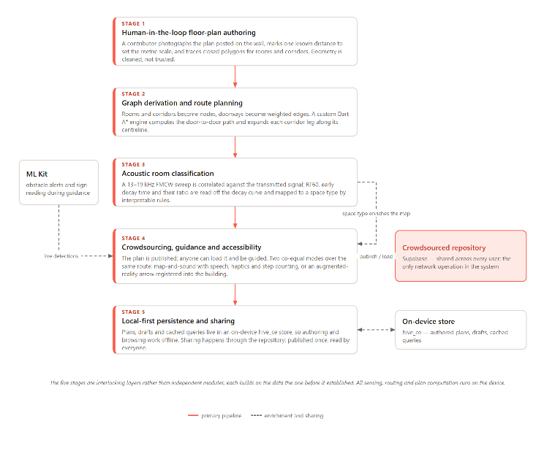
Figure 2.1: EchoLocate Conceptual Design — the Five-Stage Authoring, Mapping and Navigation Pipeline
2.9 SUMMARY
This chapter reviewed four systems — MagicPlan, Google Measure / AR Ruler Apps, the Leica BLK360 and RoomScan Pro — identifying the features, strengths and limitations of each against EchoLocate’s target capabilities across nine functional criteria.
Current systems are constrained by hardware dependency, platform exclusivity, cloud reliance, and the absence of indoor navigation, crowdsourced maps and accessibility. Five research gaps justify EchoLocate’s design, and the proposed system addresses all five by combining human-in-the-loop authoring with acoustic classification, crowdsourced sharing, graph-based navigation in two co-equal modes and an accessibility mode, from a single Flutter codebase. Section 2.8 described the five-stage pipeline realising these goals.

CHAPTER THREE: METHODOLOGY

3.1 Introduction
This chapter presents the methodology used to design and develop EchoLocate, covering system architecture, component design, requirements, software process model, logical design and development tools. All are shaped by the Chapter One constraints — commodity phones without LiDAR or depth hardware, on-device privacy-preserving sensing, accessibility for blind and low-vision users — and respond to the five research gaps of Chapter Two.

3.2 Architecture of the Proposed System
EchoLocate adopts a local-first, layered client architecture with a thin cloud tier, so each layer is developed and tested independently. The presentation layer is a Flutter application using flutter_bloc for state and Go Router for navigation; each screen owns a Bloc exposing loading, error and data states, and live-sensing screens subscribe to long-lived services rather than opening hardware themselves. Beneath it, a repository layer exposes typed models — buildings, floors, room plans, landmarks, routes — behind abstract interfaces, so on-device and cloud implementations are interchangeable. The sensing and processing layer is the analytical core: it derives a navigable graph from traced geometry, routes over it with a custom A* engine, registers routes into the ARCore world frame, runs ML Kit object and text detection, and executes the Dart-native FMCW pipeline whose reverberation features classify a space. Persistence is a hive_ce store keeping plans, drafts and cached queries available offline, with a thin Supabase tier backing the crowdsourced repository. All sensing, routing and plan computation runs on the device.
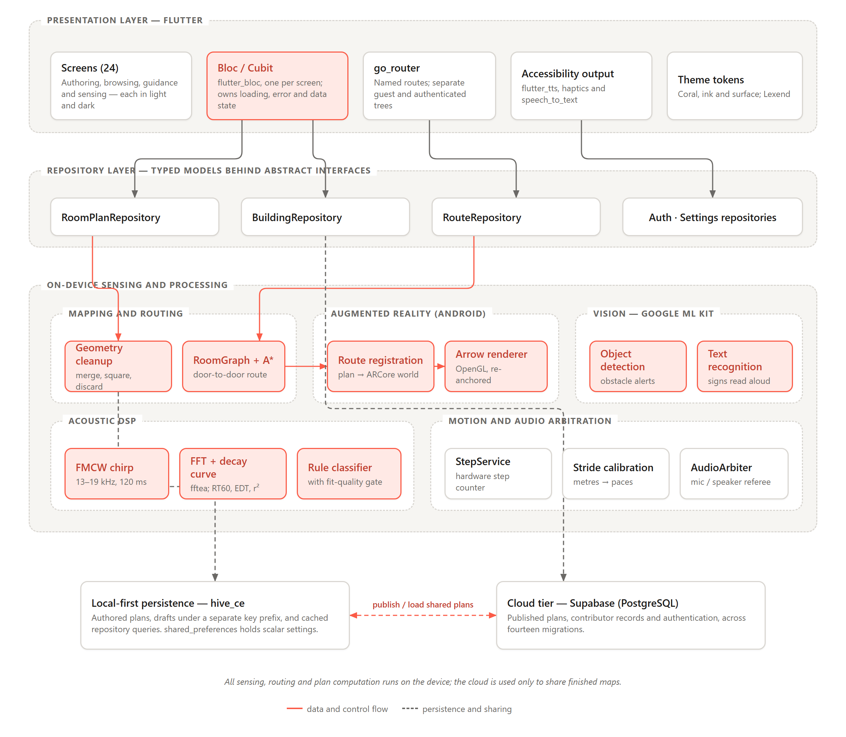
Figure 3.1: EchoLocate Layered System Architecture (On-Device Sensing with Crowdsourced Cloud Tier)

3.3 Component Design and Descriptions
EchoLocate comprises seven core components, each mapping to one or more of the objectives in Chapter One.
Component | Function
Floor-Plan Authoring Module | Captures a photograph of a posted plan and lets a contributor lay down room polygons, corridors and door openings, assign room types and set a metric scale. A draft is written on every structural change.
Graph Derivation and Routing Engine | Converts traced geometry into a navigable graph — rooms and corridors as nodes, doorways as weighted edges — computes door-to-door paths with a custom Dart A*, expands each leg along the corridor centreline, and converts the node path into turn-by-turn instructions.
AR Route Registration and Guidance Layer | Computes the similarity transform carrying plan coordinates into the ARCore world frame from one known position and one observed heading, lays the route into the room, and re-anchors at every confirmed landmark. Reports along-leg distance as a refinement only.
Semantic Detection Module | Runs ML Kit object detection and text recognition on the live feed to raise obstacle alerts and read signage aloud, entirely on-device. Shares one camera stream with the AR layer, since ARCore holds the camera exclusively.
Acoustic DSP Pipeline | Emits a linear FMCW chirp and applies a Dart-native FFT to the response, extracting RT60, early decay time, decay linearity and usable range, and mapping them to a space type by interpretable rules. The project’s DSP contribution.
Accessibility and Motion Services | Delivers guidance as speech and haptic patterns for eyes-free use, arbitrates microphone and speaker between the voice interface and the acoustic pipeline, and counts steps against a calibrated stride.
Crowdsource & Persistence Service | Manages local-first hive_ce storage and synchronises published plans with Supabase — upload, browsing, loading and contributor records.
Table 3.1: EchoLocate System Components
The acoustic pipeline is parameterised for reliable operation across commodity speakers and microphones. Table 3.2 summarises its key FMCW signal parameters.
Parameter | Value / Range | Purpose
Chirp type | Linear FMCW (up-sweep) | Wide-band excitation that can be correlated against the transmitted sweep to recover the room’s impulse response.
Frequency sweep | 13 kHz – 19 kHz | Near-ultrasonic band above almost all speech, footstep and HVAC energy, so ambient noise contributes little; also faint or inaudible to most listeners. Bandwidth stays 6 kHz, so range resolution is unaffected.
Chirp duration | 120 ms per sweep | Matched-filter gain follows the time–bandwidth product: at 6 kHz, 120 ms gives TB ≈ 720 (≈ 28.6 dB) against 240 (≈ 24 dB) at 40 ms. Pulse width is set by bandwidth, not duration.
Sampling rate | 44.1 kHz | Standard mobile rate; satisfies Nyquist for the 19 kHz bound with margin for microphone roll-off.
FFT window | Hann-windowed, applied over the correlated response | Balances spectral resolution against latency for reverberation feature extraction.
Feature set | RT60, early decay time (EDT), EDT/RT60 ratio, decay-fit r², usable decay range (dB) | Reverberation descriptors for the rule-based classifier. The r² and decay-range tests gate the fit, requiring it to be linear and to span at least 10 dB. As §4.3.6 reports, a decay far too fast to be a room can satisfy both, so the gate does not by itself establish that a measurement is physical.
Table 3.2: FMCW Acoustic Sensing Parameters
The Semantic Detection Module targets a small, navigation-relevant set of object and text classes. Table 3.3 lists the targets and how each is used on the floor plan.
Detection Target | ML Kit Capability | Use in EchoLocate
Doors and doorways | Object detection | Marked as graph connection points between spaces so the navigation engine can route between rooms.
Obstacles (furniture, pillars) | Object detection | Flagged on the floor plan and used for real-time obstacle alerts during navigation.
Room numbers and signs | Text recognition (OCR) | Attached as semantic labels to spaces, enabling destination search by room name or number.
Directional / exit signage | Text recognition (OCR) | Used to annotate exits and assist wayfinding, including spoken cues in accessibility mode.
Table 3.3: On-Device Semantic Detection Targets (Google ML Kit)

3.4 Evaluation and Analysis of Software System Type
EchoLocate is a mobile-first, sensor-driven spatial computing application. It is primarily stand-alone: authoring, graph derivation, routing, acoustic classification, semantic detection and persistence all execute locally and remain available offline. When online it also acts as a client to the Supabase repository. Because it is an assistive-navigation tool rather than a regulated safety system, the design treats output as guidance complementing the user’s judgement, gives redundant visual, audio and haptic feedback, and keeps the route independent of any optional sensing layer — landmarks decide progress, while distance and pose refine it.

3.5 Functional Requirements of the Proposed System
The functional requirements below derive from the Chapter One objectives, each mapping to at least one of the five research gaps in Chapter Two.
- FR-01: Allow a contributor to author a metrically scaled 2D floor plan by tracing a photographed posted plan or the space itself, producing room polygons, corridors, doorways and room type labels.
- FR-02: Derive a navigable graph from traced geometry, with rooms and corridors as nodes and doorways as weighted edges, and extract corridor centrelines as the walkable spine.
- FR-03: Detect obstacles and read room numbers and signage on the live camera feed using on-device Google ML Kit, raising alerts and spoken callouts during navigation.
- FR-04: Emit an FMCW chirp and apply an FFT pipeline to extract reverberation features and classify the type of space a user is in, rejecting estimates that fail a fit-quality gate.
- FR-05: Allow contributors to publish authored floor plans to a crowdsourced repository and any user to browse, load, and navigate plans contributed by others.
- FR-06: Compute door-to-door indoor routes over a loaded floor plan using a graph-based A* engine and convert the node path into turn-by-turn instructions.
- FR-07: Deliver a planned route as a drawn line over the floor plan with spoken instructions, haptic cues and step counting, requiring no camera and no ARCore.
- FR-08: Register a planned route into the ARCore world frame from one known position and one observed heading, presenting a waypoint arrow in the building and re-anchoring at every confirmed landmark.
- FR-09: Calibrate an individual walker’s stride length so that stored distances are spoken in that user’s own paces, falling back to a documented default when uncalibrated.
- FR-10: Persist authored plans, unpublished drafts and cached repository queries in a local-first on-device store, keeping authoring and browsing fully available offline.

3.6 Identification of Stakeholders
Five stakeholder groups are identified. Sighted end users author plans, publish them and follow turn-by-turn navigation by map and sound or with the AR overlay; their needs drive the core authoring and routing workflows. Blind and low-vision users are equally central, shaping the map-and-sound mode, the redundant audio and haptic cues and the obstacle alerts — the reason guidance was built to work without a camera or ARCore. Community contributors trace and publish maps, and the repository’s value depends on their participation, so contributing must be simple. Building administrators are indirect stakeholders wanting accurate, navigable maps of their premises. The developer and maintainer maintains the Supabase backend, re-fits classifier thresholds and resolves deployment issues after handover.

3.7 Requirement Gathering Process
Requirements were gathered three ways. Literature and gap synthesis drew on Chapter Two’s review, mapping each of the five gaps to at least one functional requirement in Section 3.5. Comparative analysis examined the four tools against the capabilities EchoLocate targets, identifying functionality worth replicating and limitations worth addressing. Standards review consulted WCAG 2.1 for the accessibility mode and redundant non-visual feedback, and Ghana’s Data Protection Act 2012 (Act 843) for the on-device, data-minimising design.

3.8 Requirement Specification

3.8.1 Functional User Requirements
ID | User Requirement | Stakeholder
FUR-01 | As a contributor, I want to trace a floor plan from the plan posted on a building’s wall, so a metrically scaled 2D plan of the storey is produced without special hardware. | Community Contributor
FUR-02 | As a user, I want the app to read room signs and warn me of obstacles, so I know where I am and what is in front of me. | Sighted / Low-Vision User
FUR-03 | As a contributor, I want to publish the plans I author and browse plans shared by others, so I can navigate buildings I have never mapped. | Community Contributor
FUR-04 | As a user, I want turn-by-turn directions to a room within a loaded building, so I can find my destination indoors. | Sighted User
FUR-05 | As a blind or low-vision user, I want spoken directions and haptic feedback, so I can navigate indoors without looking at the screen. | Blind / Low-Vision User
FUR-06 | As a user, I want the app to keep working without internet, so I can author and navigate where connectivity is poor. | Sighted / Low-Vision User
FUR-07 | As a sighted user, I want an arrow laid into the building itself, so I can see where to go rather than read a map. | Sighted User
Table 3.4: Functional User Requirements

3.8.2 Functional System Requirements
ID | System Requirement | Satisfies
FSR-01 | The system shall let a contributor trace closed room and corridor polygons with door openings against a photographed plan, establish a metric scale from one known distance, and clean the geometry. | FUR-01
FSR-02 | The system shall derive a navigable graph from traced geometry — rooms and corridors as nodes, doorways as weighted edges — and extract corridor centrelines. | FUR-01, FUR-04
FSR-03 | The system shall run on-device ML Kit object and text detection, raising obstacle alerts and reading room numbers and signage aloud. | FUR-02
FSR-04 | The system shall classify the type of space from FMCW reverberation features by interpretable rules, rejecting estimates that fail a fit-quality and decay-range gate. | FUR-01
FSR-05 | The system shall publish floor plans to the Supabase repository and list, load, and open community plans. | FUR-03
FSR-06 | The system shall compute a door-to-door A* route and present it both as a drawn line with spoken turn-by-turn steps and as an AR arrow registered into the building. | FUR-04, FUR-07
FSR-07 | The system shall deliver spoken guidance through flutter_tts with haptic cues and hardware step counting against a calibrated stride, and accept voice commands via speech_to_text. | FUR-05
FSR-08 | The system shall persist authored plans, drafts and cached repository queries in a local-first hive_ce store, isolating drafts from published plans by key prefix. | FUR-06
Table 3.5: Functional System Requirements

3.8.3 UML Diagrams
Use Case Diagram 1 — Mobile Application (Front-End)
The front-end use case diagram captures the interactions available to the Sighted User and the Blind / Low-Vision User: tracing and publishing a plan, browsing community plans, navigating by map and sound, and using the AR overlay.
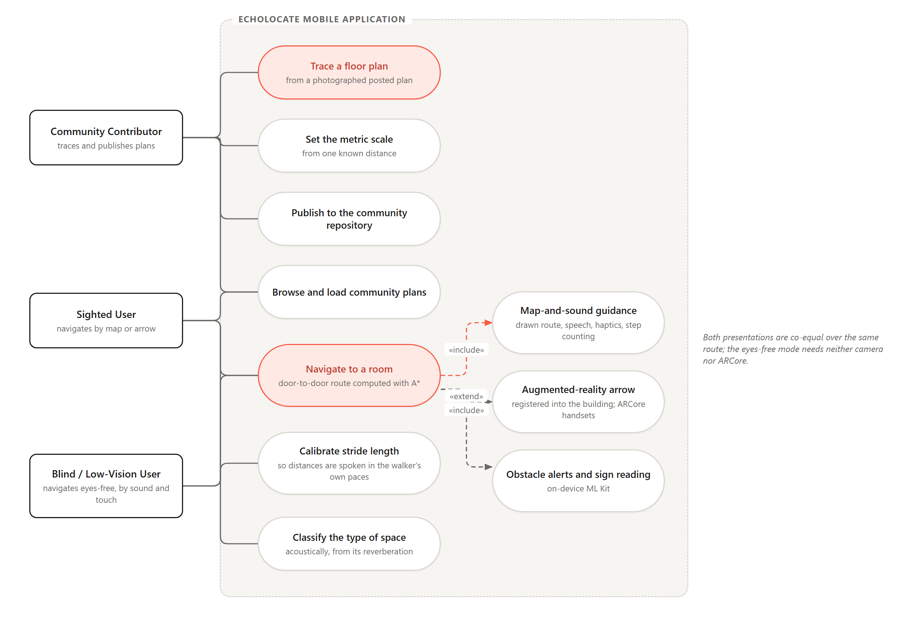
Figure 3.2: Use Case Diagram — EchoLocate Mobile Application (Front-End)
Use Case Diagram 2 — Crowdsource Backend (Back-End)
The back-end use case diagram covers the Supabase repository: publishing an authored plan, browsing and loading community plans, and synchronising contributor records.
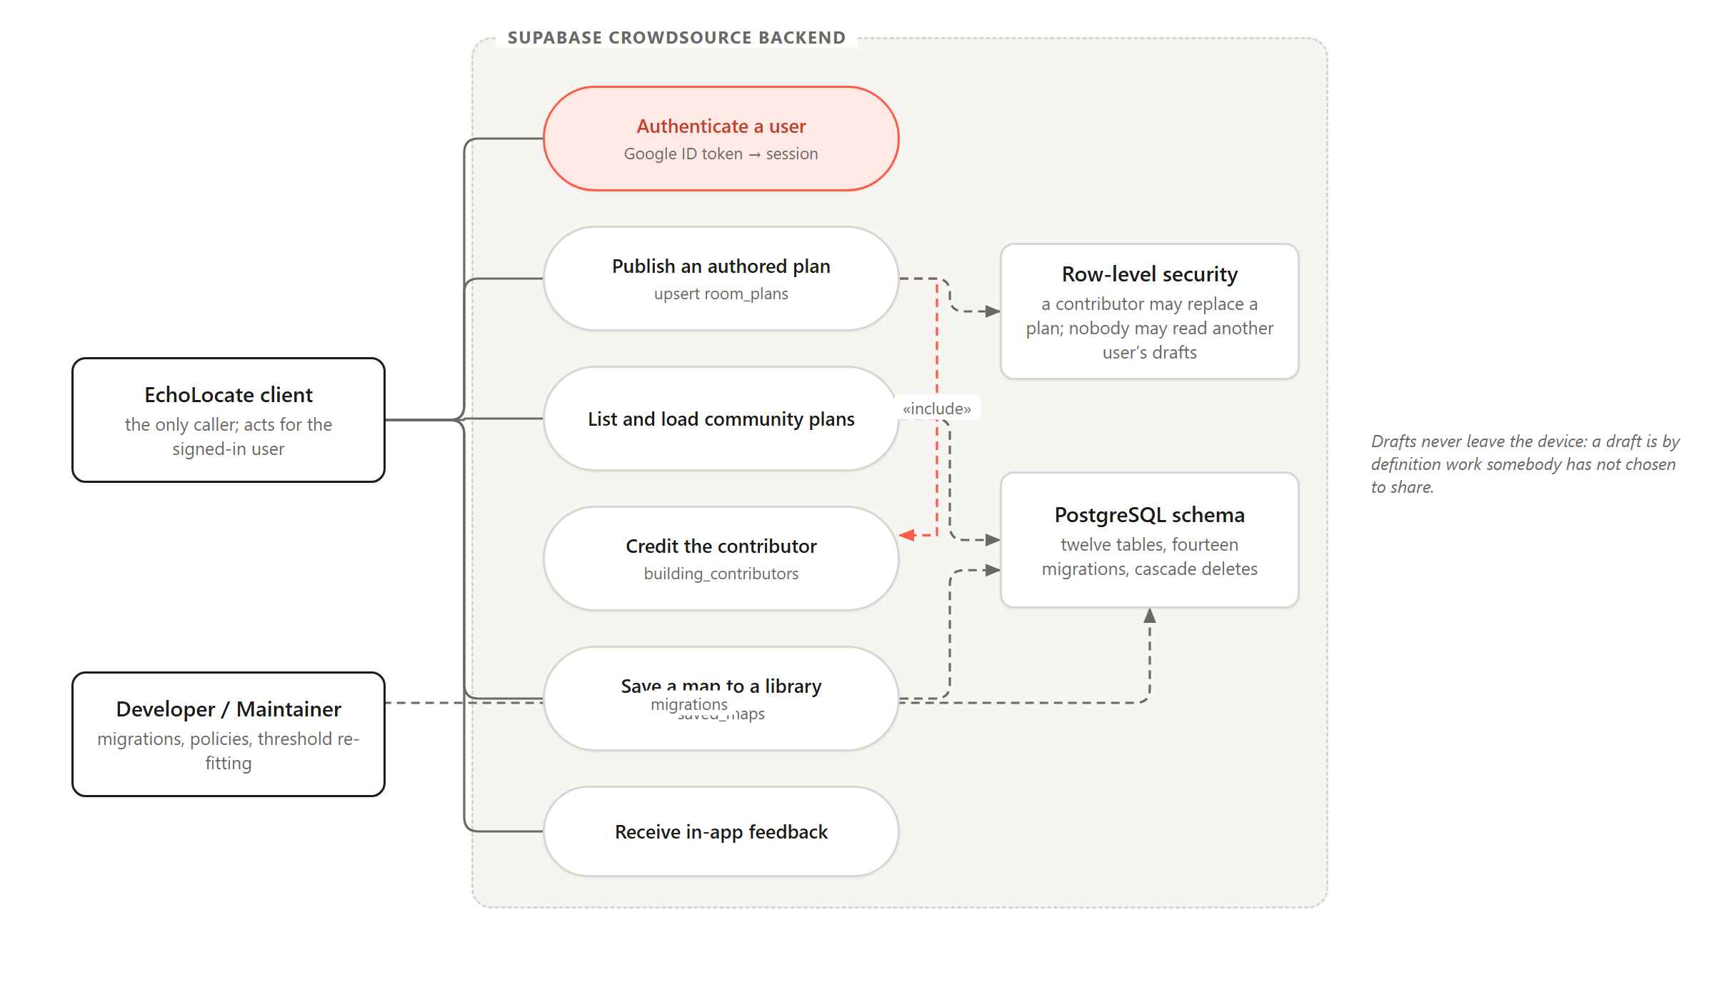
Figure 3.3: Use Case Diagram — EchoLocate Crowdsource Backend (Back-End)
Use Case Description — UC-01: Author and Publish a Floor Plan
Element | Description
Actor(s) | Community Contributor, Mobile Device Camera
Precondition | Camera permission is granted, and the contributor is standing in the space or has the building’s posted floor plan in view.
Main Flow | 1. Contributor photographs the posted floor plan, or begins tracing the space directly. 2. Contributor marks one known real-world distance to establish a metric scale. 3. Contributor traces closed polygons for each room and corridor and assigns a room type to each. 4. Contributor marks the door openings on shared walls. 5. System cleans the traced geometry, merging near-coincident corners and squaring near-orthogonal walls. 6. System derives the navigable graph and persists the plan. 7. Contributor publishes the plan to the crowdsourced repository.
Alternative Flow | A draft is written on every structural change, so an interrupted trace can be resumed rather than lost. A large floor may be traced a wing at a time, the wings reconciled by dragging one into place against another.
Postcondition | A metrically scaled 2D floor plan and its derived graph are persisted locally and, once published, available to other users for navigation.
Performance | Tracing a single storey shall take roughly twenty minutes, and graph derivation shall complete within a second of the trace being closed.
Table 3.6: Use Case Description — UC-01: Author and Publish a Floor Plan
Use Case Description — UC-02: Navigate to a Room
Element | Description
Actor(s) | Sighted User, Blind / Low-Vision User
Precondition | A floor plan for the building has been loaded, either authored locally or downloaded from the crowdsourced repository.
Main Flow | 1. User selects or speaks a destination room.  2. System builds a navigation graph from the floor plan and computes the shortest route using A*.  3. System presents turn-by-turn steps with a 2D map and an AR waypoint overlay.  4. ML Kit raises real-time obstacle alerts as the user proceeds.  5. System announces arrival at the destination.
Alternative Flow | In accessibility mode the route is delivered entirely through speech and haptic cues (for example “Turn right in 5 metres”), the screen overlay is optional, and voice commands control the session.
Postcondition | The user is guided from the start point to the destination, with the session recorded in local history.
Performance | Route computation shall complete within one second for a typical single-building floor plan after the destination is selected.
Table 3.7: Use Case Description — UC-02: Navigate to a Room
Activity Diagram — Floor-Plan Authoring
The activity diagram models the authoring workflow, from establishing a metric scale and tracing polygons through geometry cleanup and graph derivation to draft persistence and publication.
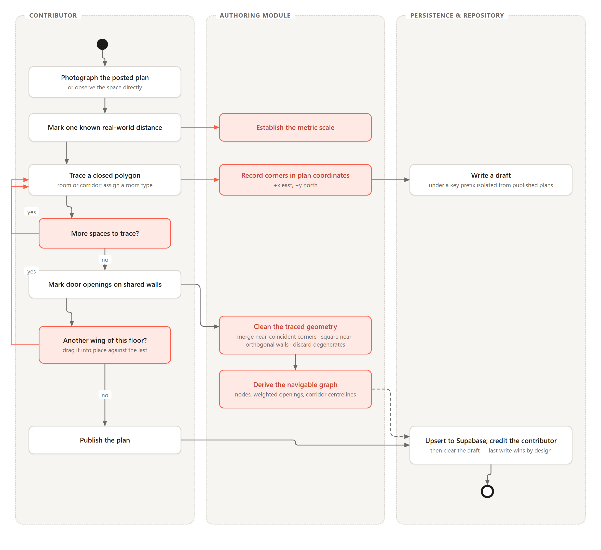
Figure 3.4: Activity Diagram — Floor-Plan Authoring Flow
Activity Diagram — Indoor Navigation
The second activity diagram models the navigation workflow, from loading a map and selecting a destination through A* routing, turn-by-turn guidance, obstacle alerts and the accessibility voice-and-haptic branch.
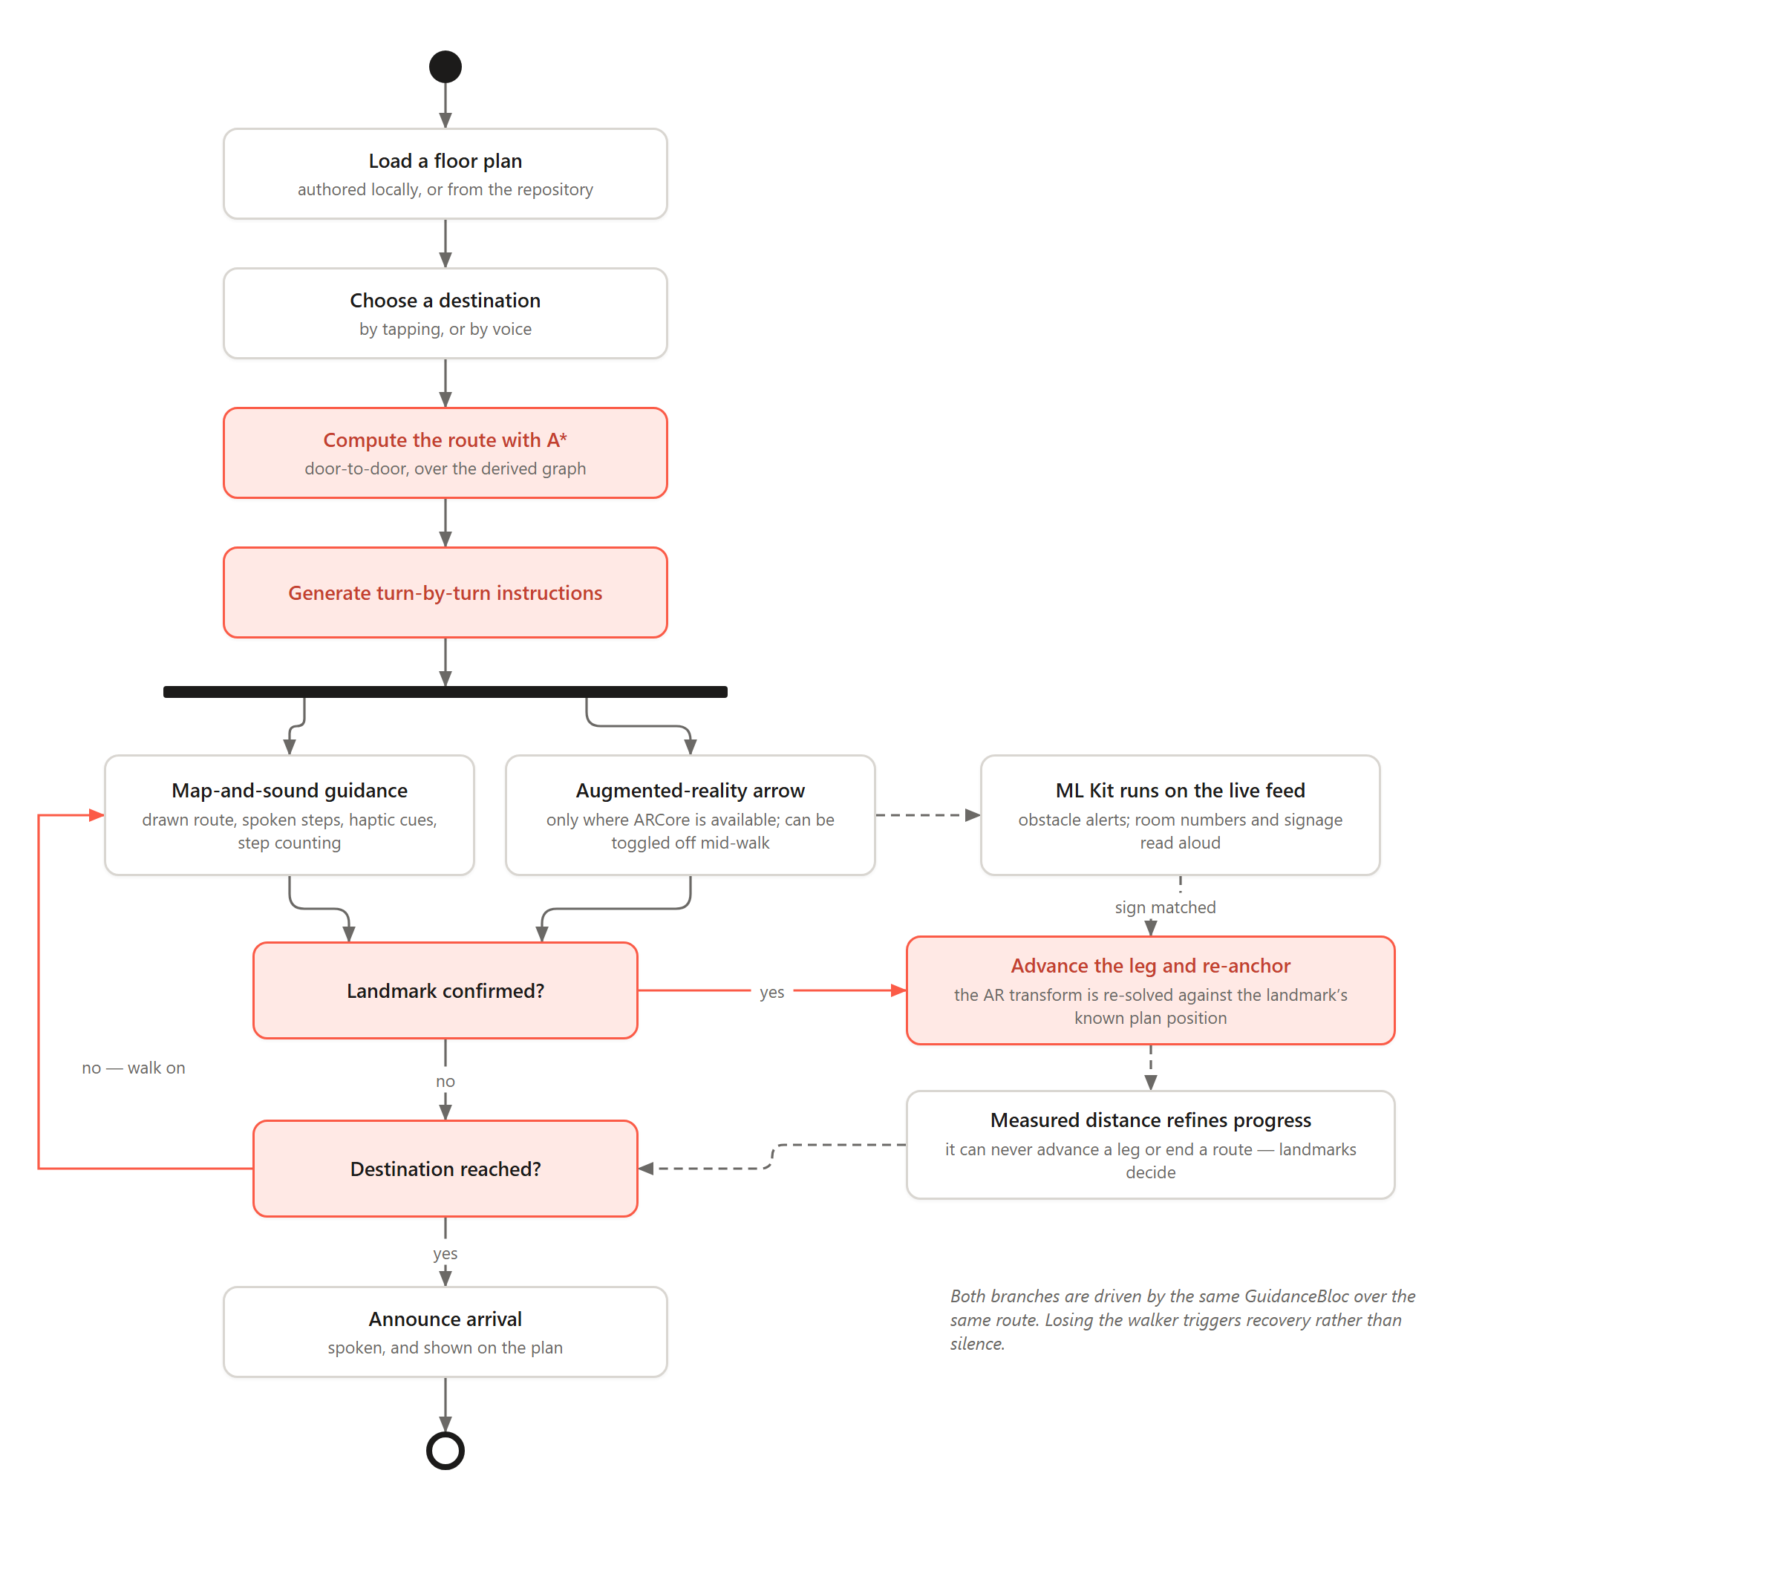
Figure 3.5: Activity Diagram — Indoor Navigation Flow
Sequence Diagram — Author and Publish a Floor Plan
The authoring sequence diagram shows the message exchange between the contributor, the Flutter UI, the Floor-Plan Authoring Module, the Graph Derivation and Routing Engine, the local hive_ce store and the Crowdsource & Persistence Service.
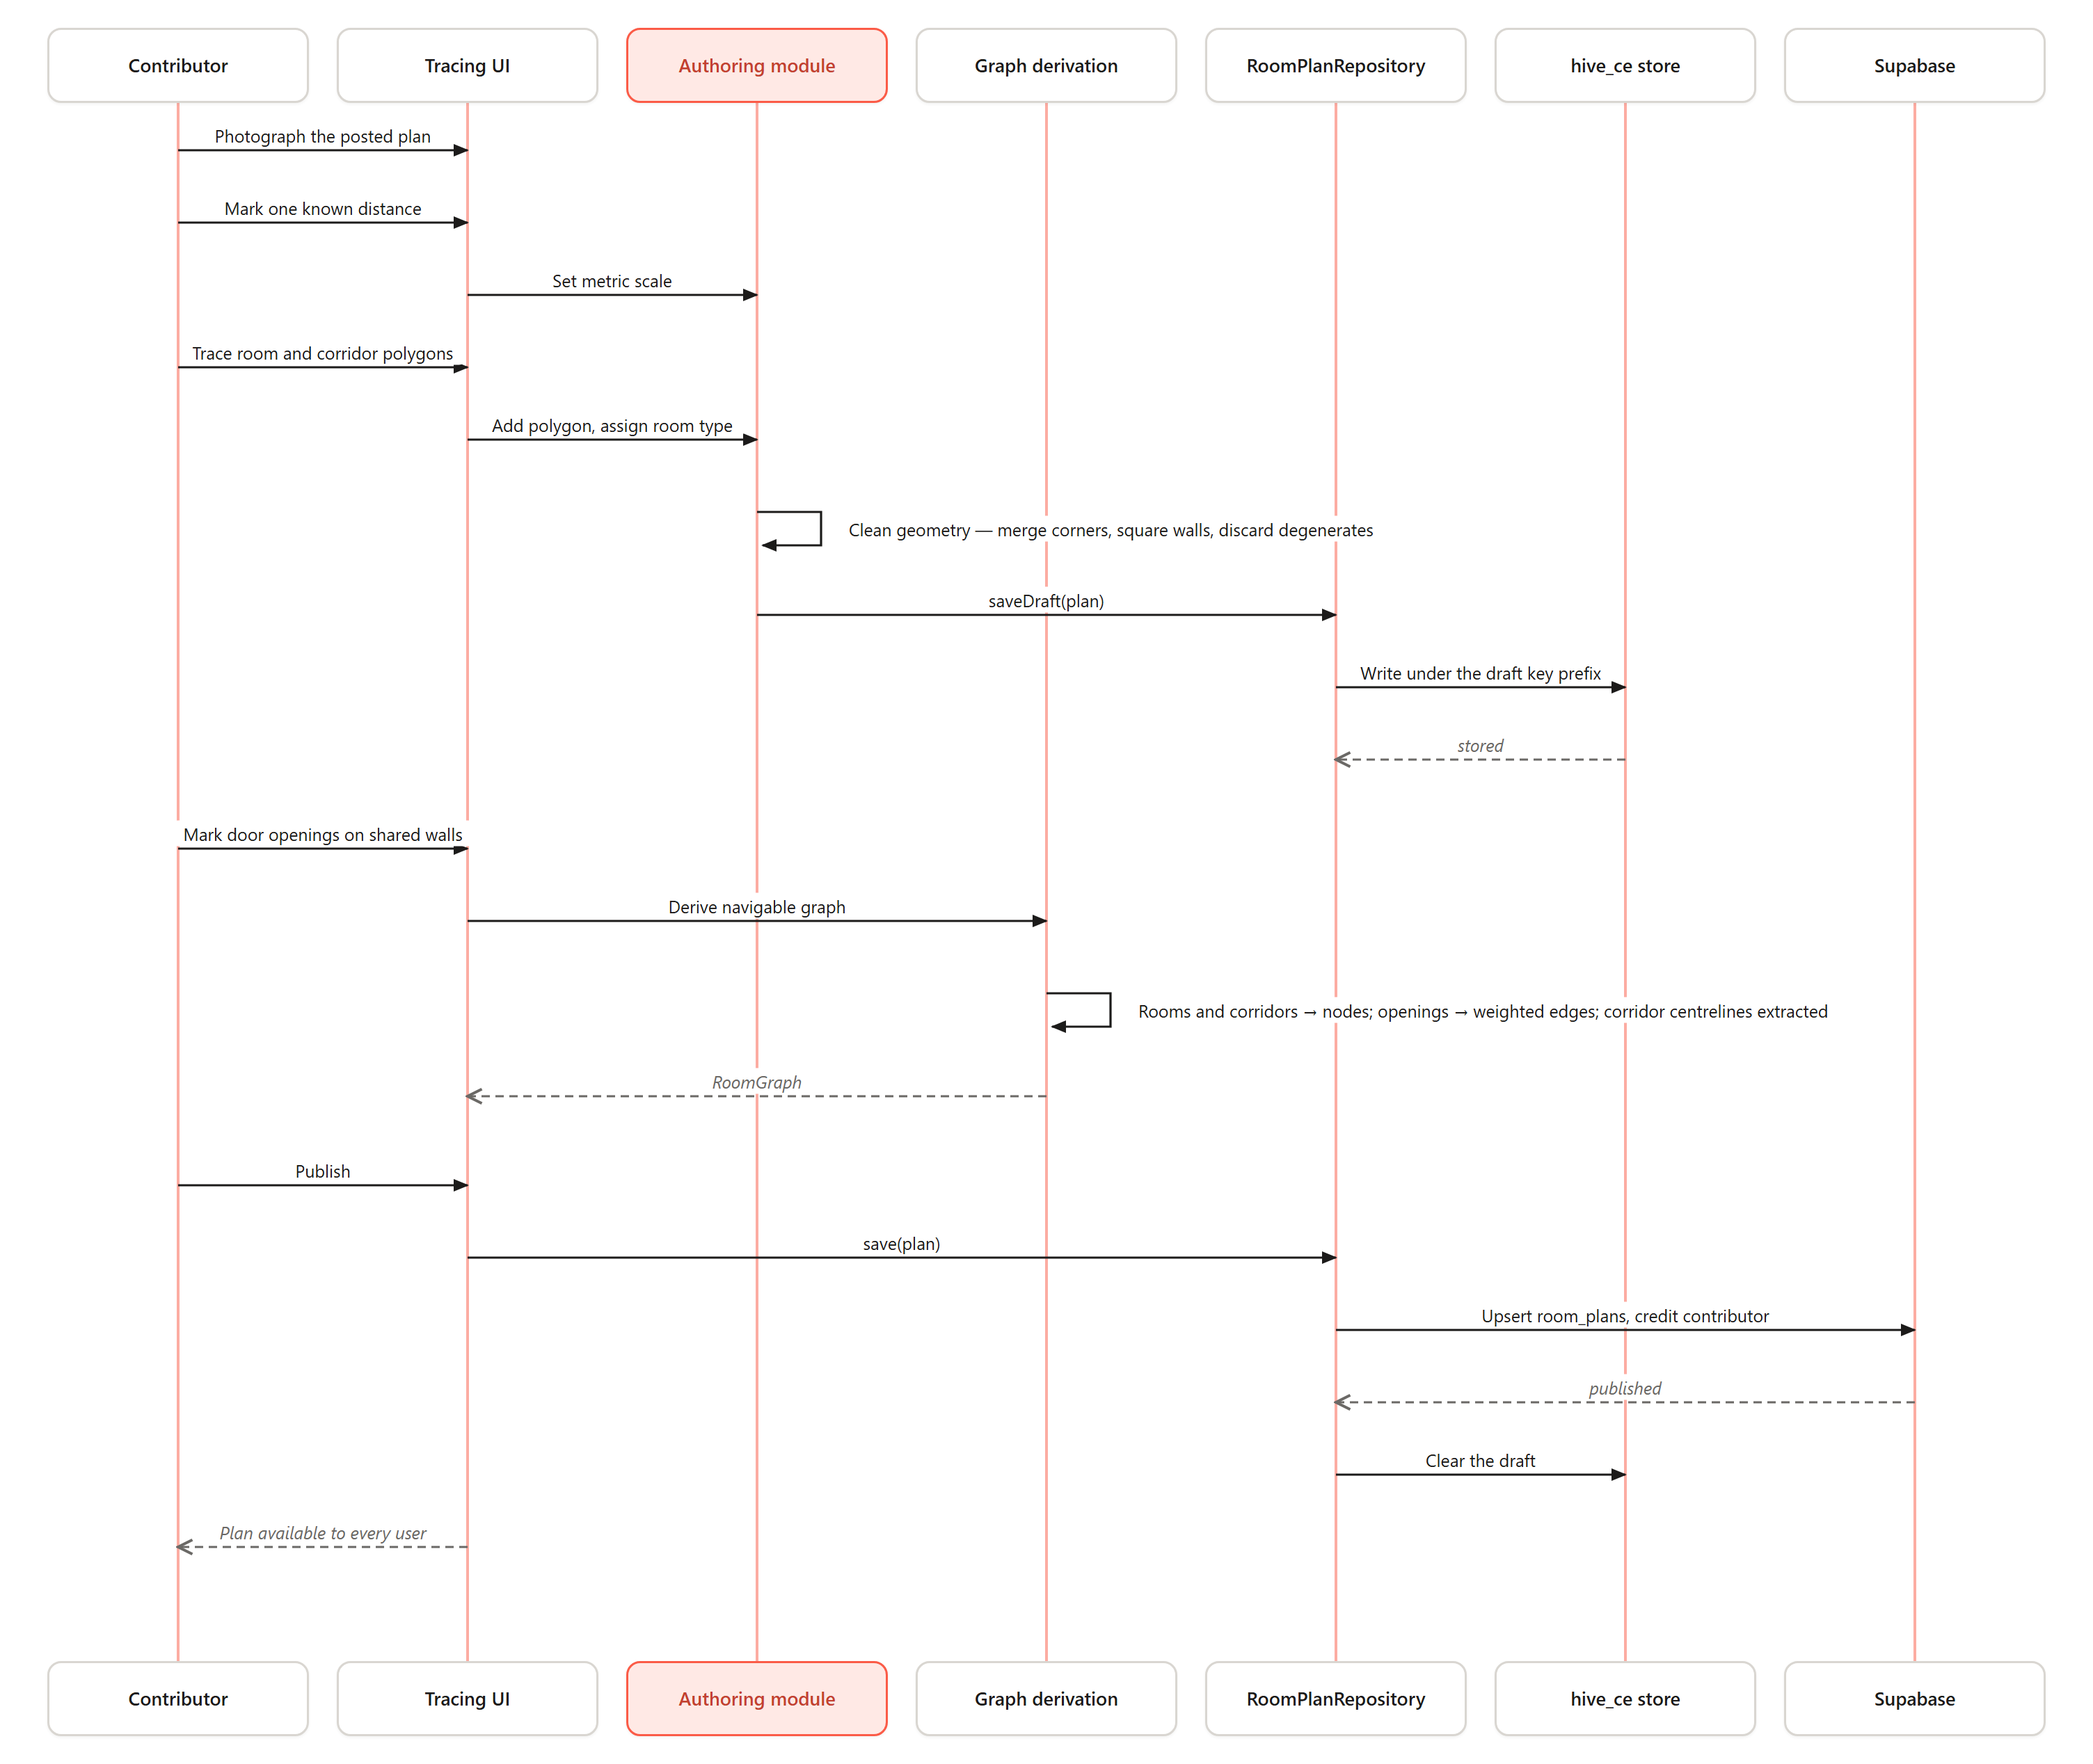
Figure 3.6: Sequence Diagram — Author and Publish a Floor Plan
Sequence Diagram — Navigate to a Room
The navigation sequence diagram shows the interaction between the user, the Flutter UI, the Map Repository, the Navigation Engine, the Accessibility Service and the Semantic Detection Module during a routing session.
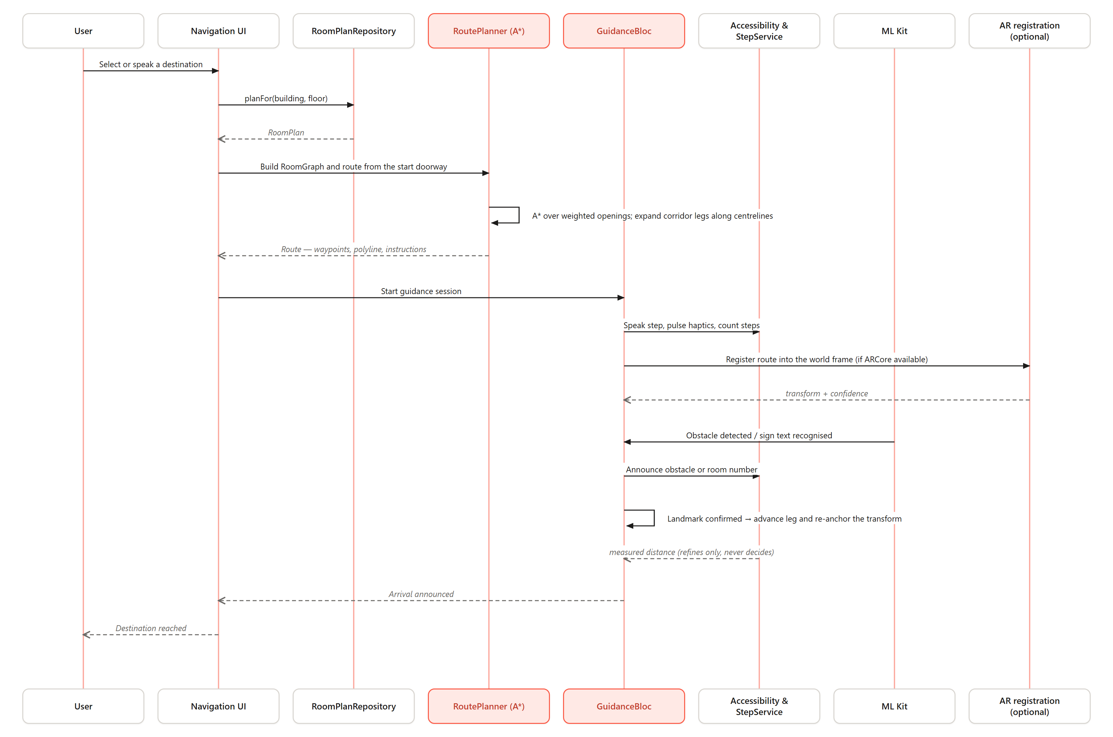
Figure 3.7: Sequence Diagram — Navigate to a Room

3.9 Non-Functional Requirements
ID | Category | Requirement | Justification
NFR-01 | Performance | Route computation shall complete within 1 second for a typical single-building floor plan on a mid-range Android device. | Consistent with user tolerance thresholds (Nielsen, 1994); responsiveness is essential for live wayfinding.
NFR-02 | Performance | Geometry cleanup and navigable-graph derivation shall complete within one second of a traced floor being closed. | Keeps the trace-and-confirm loop tight enough for field use on commodity hardware.
NFR-03 | Reliability | Floor-plan authoring, graph derivation, routing, guidance and persistence shall remain fully functional with no internet connectivity. | Many indoor environments have weak connectivity; offline operation is core, not optional.
NFR-04 | Reliability | Navigation shall remain fully functional on handsets with no ARCore and no hardware step counter; AR and measured distance refine guidance but never decide it. | ARCore certification is a property of the handset, and most handsets in the target setting lack it.
NFR-05 | Usability / Accessibility | All navigation guidance shall be available through redundant visual, audio, and haptic channels. | Satisfies WCAG 2.1 (W3C, 2018) and makes the system usable by blind and low-vision users.
NFR-06 | Portability | The application shall run from a single Flutter codebase on Android (primary) and iOS. | Cross-platform reach is a stated objective and addresses the platform-exclusivity gap of Chapter Two.
NFR-07 | Privacy / Security | All sensing and floor-plan computation shall occur on-device; only finished maps the user chooses to share are uploaded. | Complies with the data-minimisation principle of Ghana’s Data Protection Act 2012 (Act 843).
Table 3.8: Non-Functional Requirements with Justifications

3.10 Candidate Classes and UML Class Diagram
The candidate classes below are identified from the functional requirements, each encapsulating a distinct responsibility with well-defined interfaces to adjacent classes.
Class | Layer | Responsibility
RoomPlan | Mapping | Central entity: traced polygons, corridors, openings, type labels and metric scale for one floor.
RoomPolygon | Mapping | A closed traced polygon — room or corridor — with corners in plan coordinates and a room type.
Opening | Mapping | A door opening on a shared wall, recording the two spaces it connects; becomes a weighted edge.
Landmark | Mapping | A confirmable feature at a known plan position, used to advance a leg and re-anchor AR registration.
RoomGraph | Navigation | Graph derived from a RoomPlan: rooms and corridors as nodes, openings as weighted edges.
RoutePlanner | Navigation | Custom Dart A*; computes the door-to-door path and expands each leg along the corridor centreline.
Route | Navigation | Value object: waypoints, the drawn polyline, and turn-by-turn instructions.
GuidanceBloc | Presentation | Drives a guidance session in either mode, advancing legs on confirmed landmarks.
RouteRegistration | Sensing | Solves and holds the plan-to-ARCore transform with a confidence, re-solved at every landmark.
AcousticSample | Sensing | An FMCW capture with its correlated response and energy decay curve.
ReverbFeatures | DSP | RT60, early decay time, decay-fit r² and usable decay range from a decay curve.
RoomClassifier | DSP | Applies interpretable rules over ReverbFeatures to give a space type, confidence and reason, or a rejection.
AccessibilityService | Presentation | Converts route steps into speech and haptic cues; handles voice commands.
StepService | Sensing | Wraps the hardware step counter and converts counts to distance using calibrated stride.
RoomPlanRepository | Persistence | Abstract interface over hive_ce and Supabase implementations for plans and drafts.
CrowdsourceService | Cloud | Publishes and retrieves shared plans and contributor records via Supabase.
Table 3.9: EchoLocate Candidate Classes
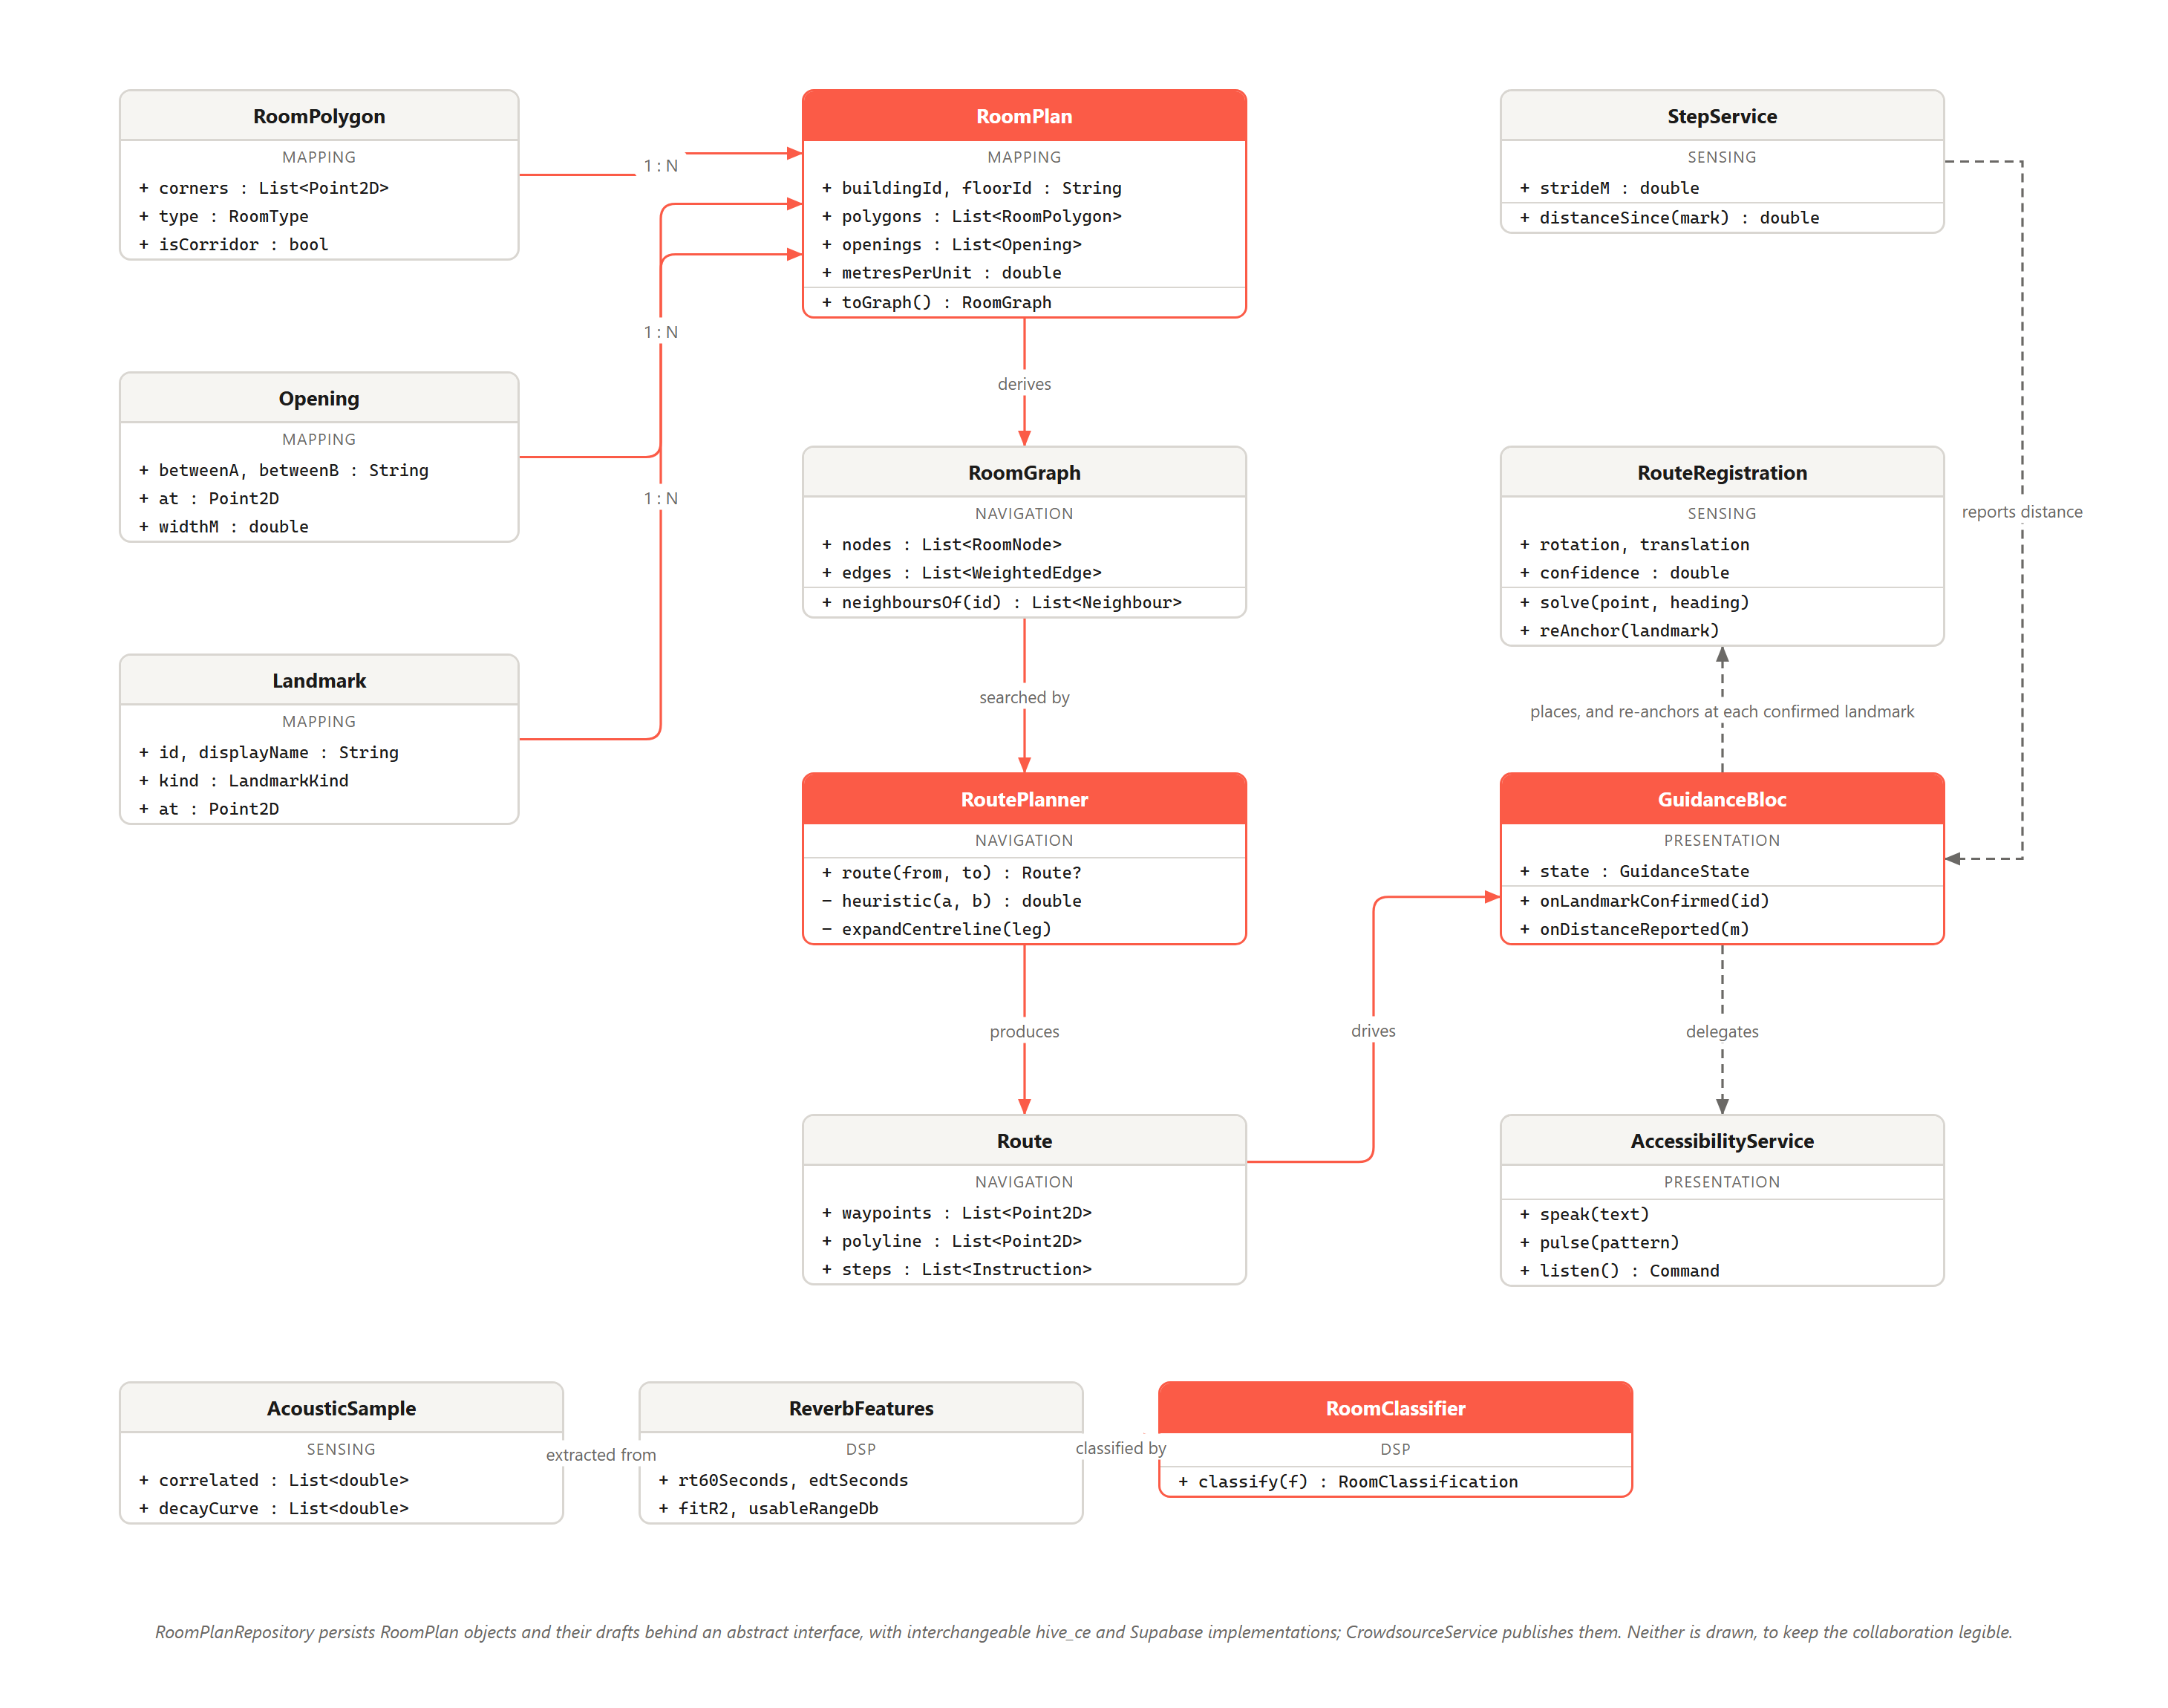
Figure 3.8: UML Class Diagram — EchoLocate System
RoomPlan is the central entity, composed of many RoomPolygon and Opening objects with the Landmarks placed on the floor, and authored rather than captured. RoomGraph is derived from it, and RoutePlanner computes a Route over that graph. GuidanceBloc drives a session from a Route, delegating non-visual output to AccessibilityService, distance to StepService and — where ARCore is available — world placement to RouteRegistration, re-solved at each confirmed Landmark. RoomClassifier consumes ReverbFeatures from an AcousticSample. RoomPlanRepository persists plans and drafts locally; CrowdsourceService synchronises published plans.

3.11 Algorithms for the System

3.11.1 Algorithm 1: Floor-Plan Authoring and Graph Derivation
Step | Operation
Input | A photograph of a posted floor plan, or the space itself; contributor input.
Step 1 | Establish a metric scale by having the contributor mark a known real-world distance on the plan.
Step 2 | Trace closed polygons for each room and corridor, capturing corners in plan coordinates (+x east, +y north).
Step 3 | Assign a room type from a fixed vocabulary chosen so every entry is identifiable from a doorway.
Step 4 | Mark door openings on shared walls, recording which two spaces each connects.
Step 5 | Clean the traced geometry: merge near-coincident corners, square near-orthogonal walls, and discard degenerate polygons.
Step 6 | Derive the navigable graph — rooms and corridors become nodes, openings weighted edges, corridor centrelines the walkable spine.
Output | A RoomPlan of room polygons, corridors, openings, type labels and a metric scale, with the graph derived from it.
Table 3.10: Algorithm 1 — Floor-Plan Authoring and Graph Derivation
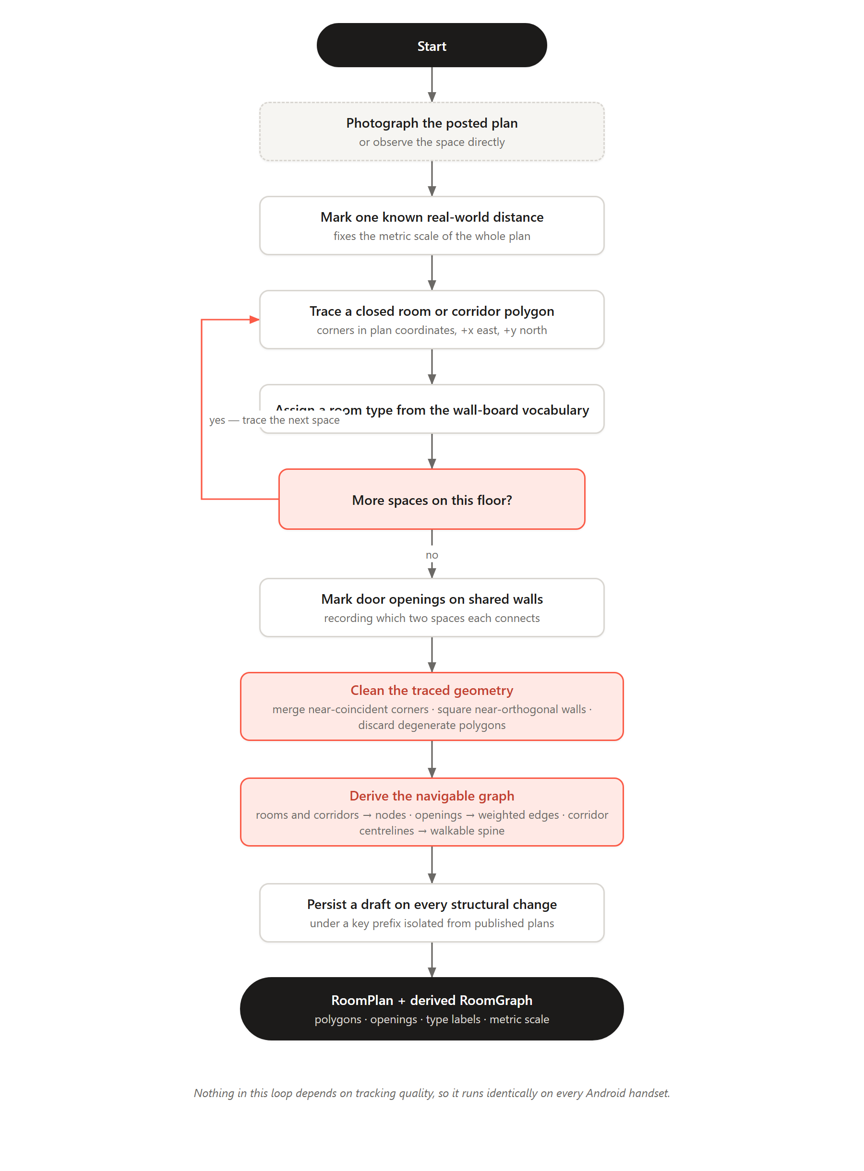
Figure 3.9: Flowchart — Floor-Plan Authoring and Graph Derivation Algorithm

3.11.2 Algorithm 2: Acoustic Room Classification
Step | Operation
Input | Microphone and speaker access; a trigger from the user or from a room-labelling action.
Step 1 | Emit a linear FMCW up-sweep of 13–19 kHz over 120 ms at 44.1 kHz and record the response. The near-ultrasonic band sits above almost all speech, footstep and HVAC energy, so ambient noise contributes little, and is faint or inaudible to most listeners.
Step 2 | Correlate the recording against the transmitted sweep. Matched-filter gain follows the time–bandwidth product: at 6 kHz, 120 ms gives TB ≈ 720 (≈ 28.6 dB), leaving range resolution unchanged.
Step 3 | Apply a windowed FFT and derive the energy decay curve of the response.
Step 4 | Fit a straight line to the decay in dB and extract RT60, early decay time (the same slope over the first 10 dB), fit quality r², and usable decay range.
Step 5 | Gate on fit quality and decay range: an estimate from noise, or from too short a capture, is rejected rather than classified.
Step 6 | Classify by rules over RT60 and the EDT/RT60 ratio. A low ratio means a non-diffuse field — a corridor, where parallel reflections shorten early decay. Short RT60 with a diffuse field is a small room; long RT60 a large hall.
Output | A space-type classification with an associated confidence, or an explicit rejection.
Table 3.11: Algorithm 2 — Acoustic Room Classification
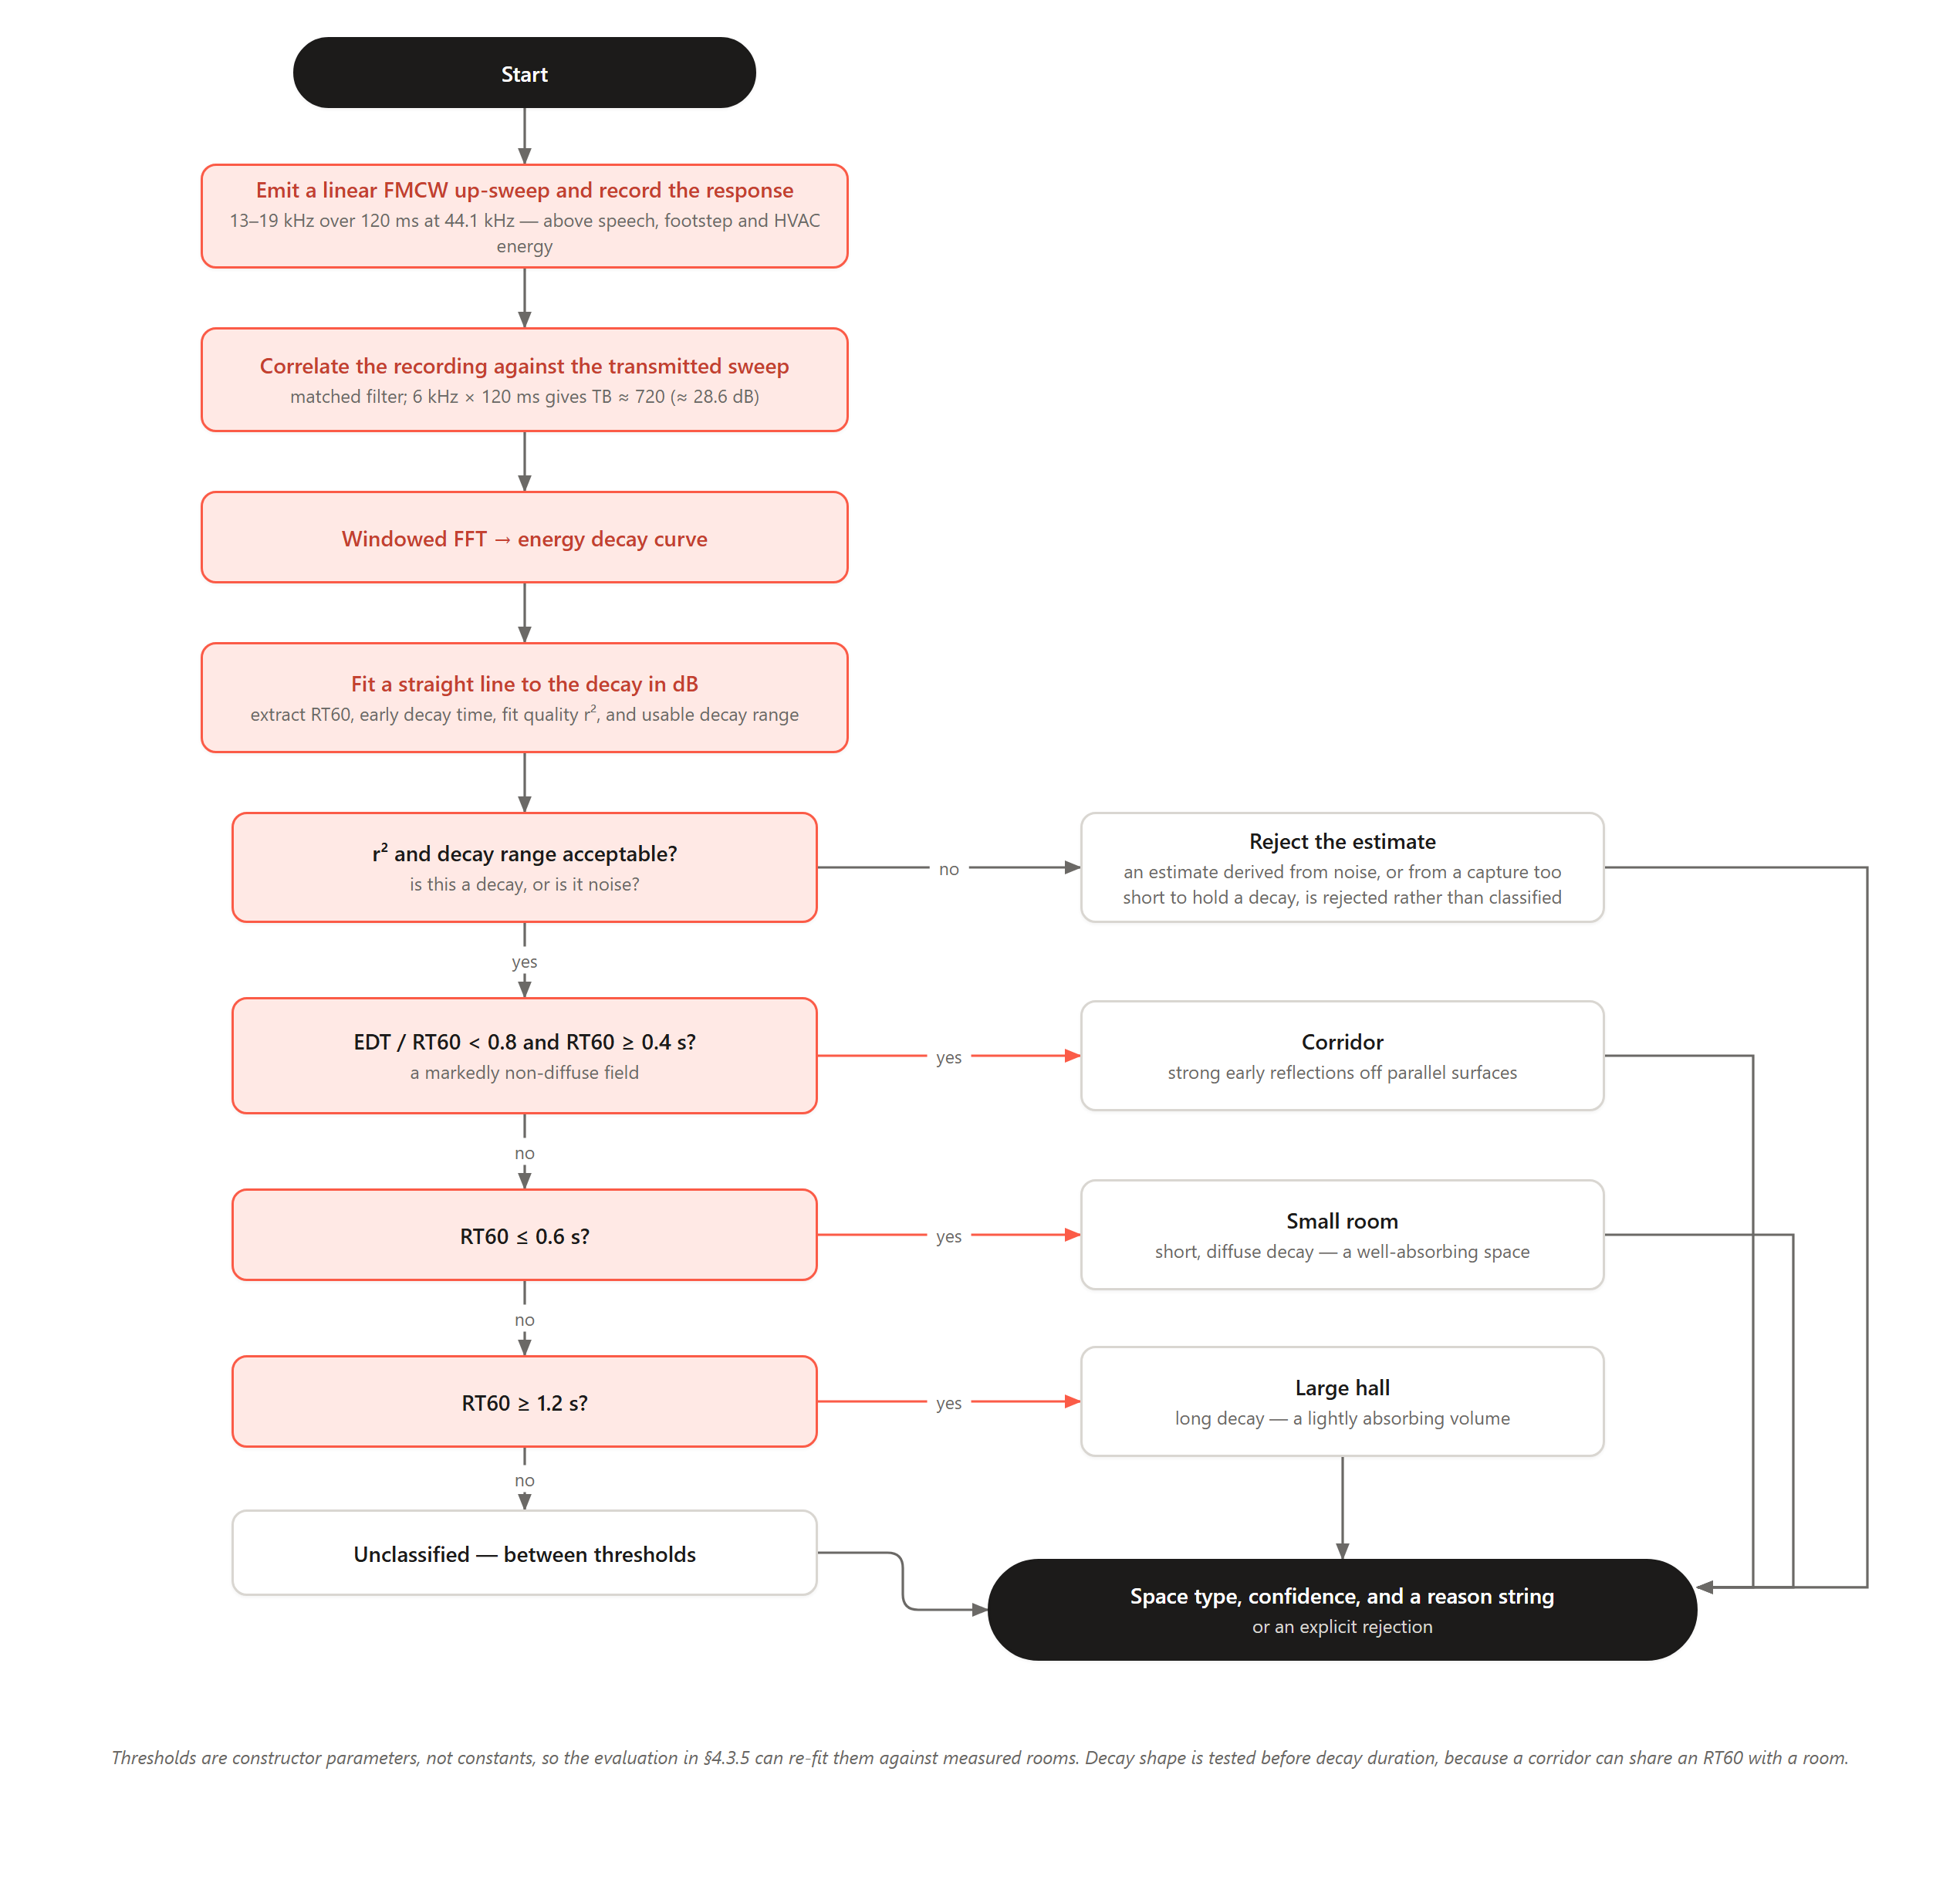
Figure 3.10: Flowchart — Acoustic Room Classification Algorithm
A rule-based classifier is preferred over a learned model. The thresholds derive from Sabine’s relation, which ties reverberation time to volume and absorption, so classes separate along RT60 for physical reasons and every decision can be defended from room acoustics. A network trained on the few samples obtainable in twelve weeks could not be, and would carry unquantified generalisation risk for little separation. The thresholds are parameters so Chapter Four’s evaluation can re-fit them, and the interface is unchanged, so a learned model can replace it later.

3.11.3 Algorithm 3: A* Indoor Navigation
Step | Operation
Input | A RoomPlan and its RoomGraph; start doorway s and destination doorway d. Both endpoints sit on doorways, not room centres, so a route begins and ends at a door the walker can see.
Step 1 | Build the RoomGraph from the RoomPlan: rooms and corridors become nodes, doorways become weighted edges carrying their real-world length.
Step 2 | Initialise the open set with s; set g(s) = 0 and f(s) = h(s, d) using a straight-line (Euclidean) heuristic, admissible because the plan preserves recorded distances.
Step 3 | WHILE the open set is not empty: take the node n with the lowest f; IF n = d, reconstruct the path and RETURN it.
Step 4 | FOR each neighbour m of n: tentative_g = g(n) + cost(n, m); IF better, update g(m), set f(m) = g(m) + h(m, d), and record the parent.
Step 5 | Expand each corridor leg along its centreline to give the polyline the walker follows, and convert the waypoints into turn-by-turn instructions — one per pair of decision points, not one per bend.
Step 6 | Deliver the route in the selected mode: map-and-sound draws the polyline and speaks each step with haptics and step counting, needing no camera or ARCore; augmented reality additionally lays a registered arrow into the building (§3.11.4). Both raise ML Kit obstacle alerts, and route, instructions and arrival logic are identical.
Output | A Route — waypoints, drawn polyline and turn-by-turn instructions — delivered in the selected mode, with obstacle alerts.
Table 3.12: Algorithm 3 — A* Indoor Navigation
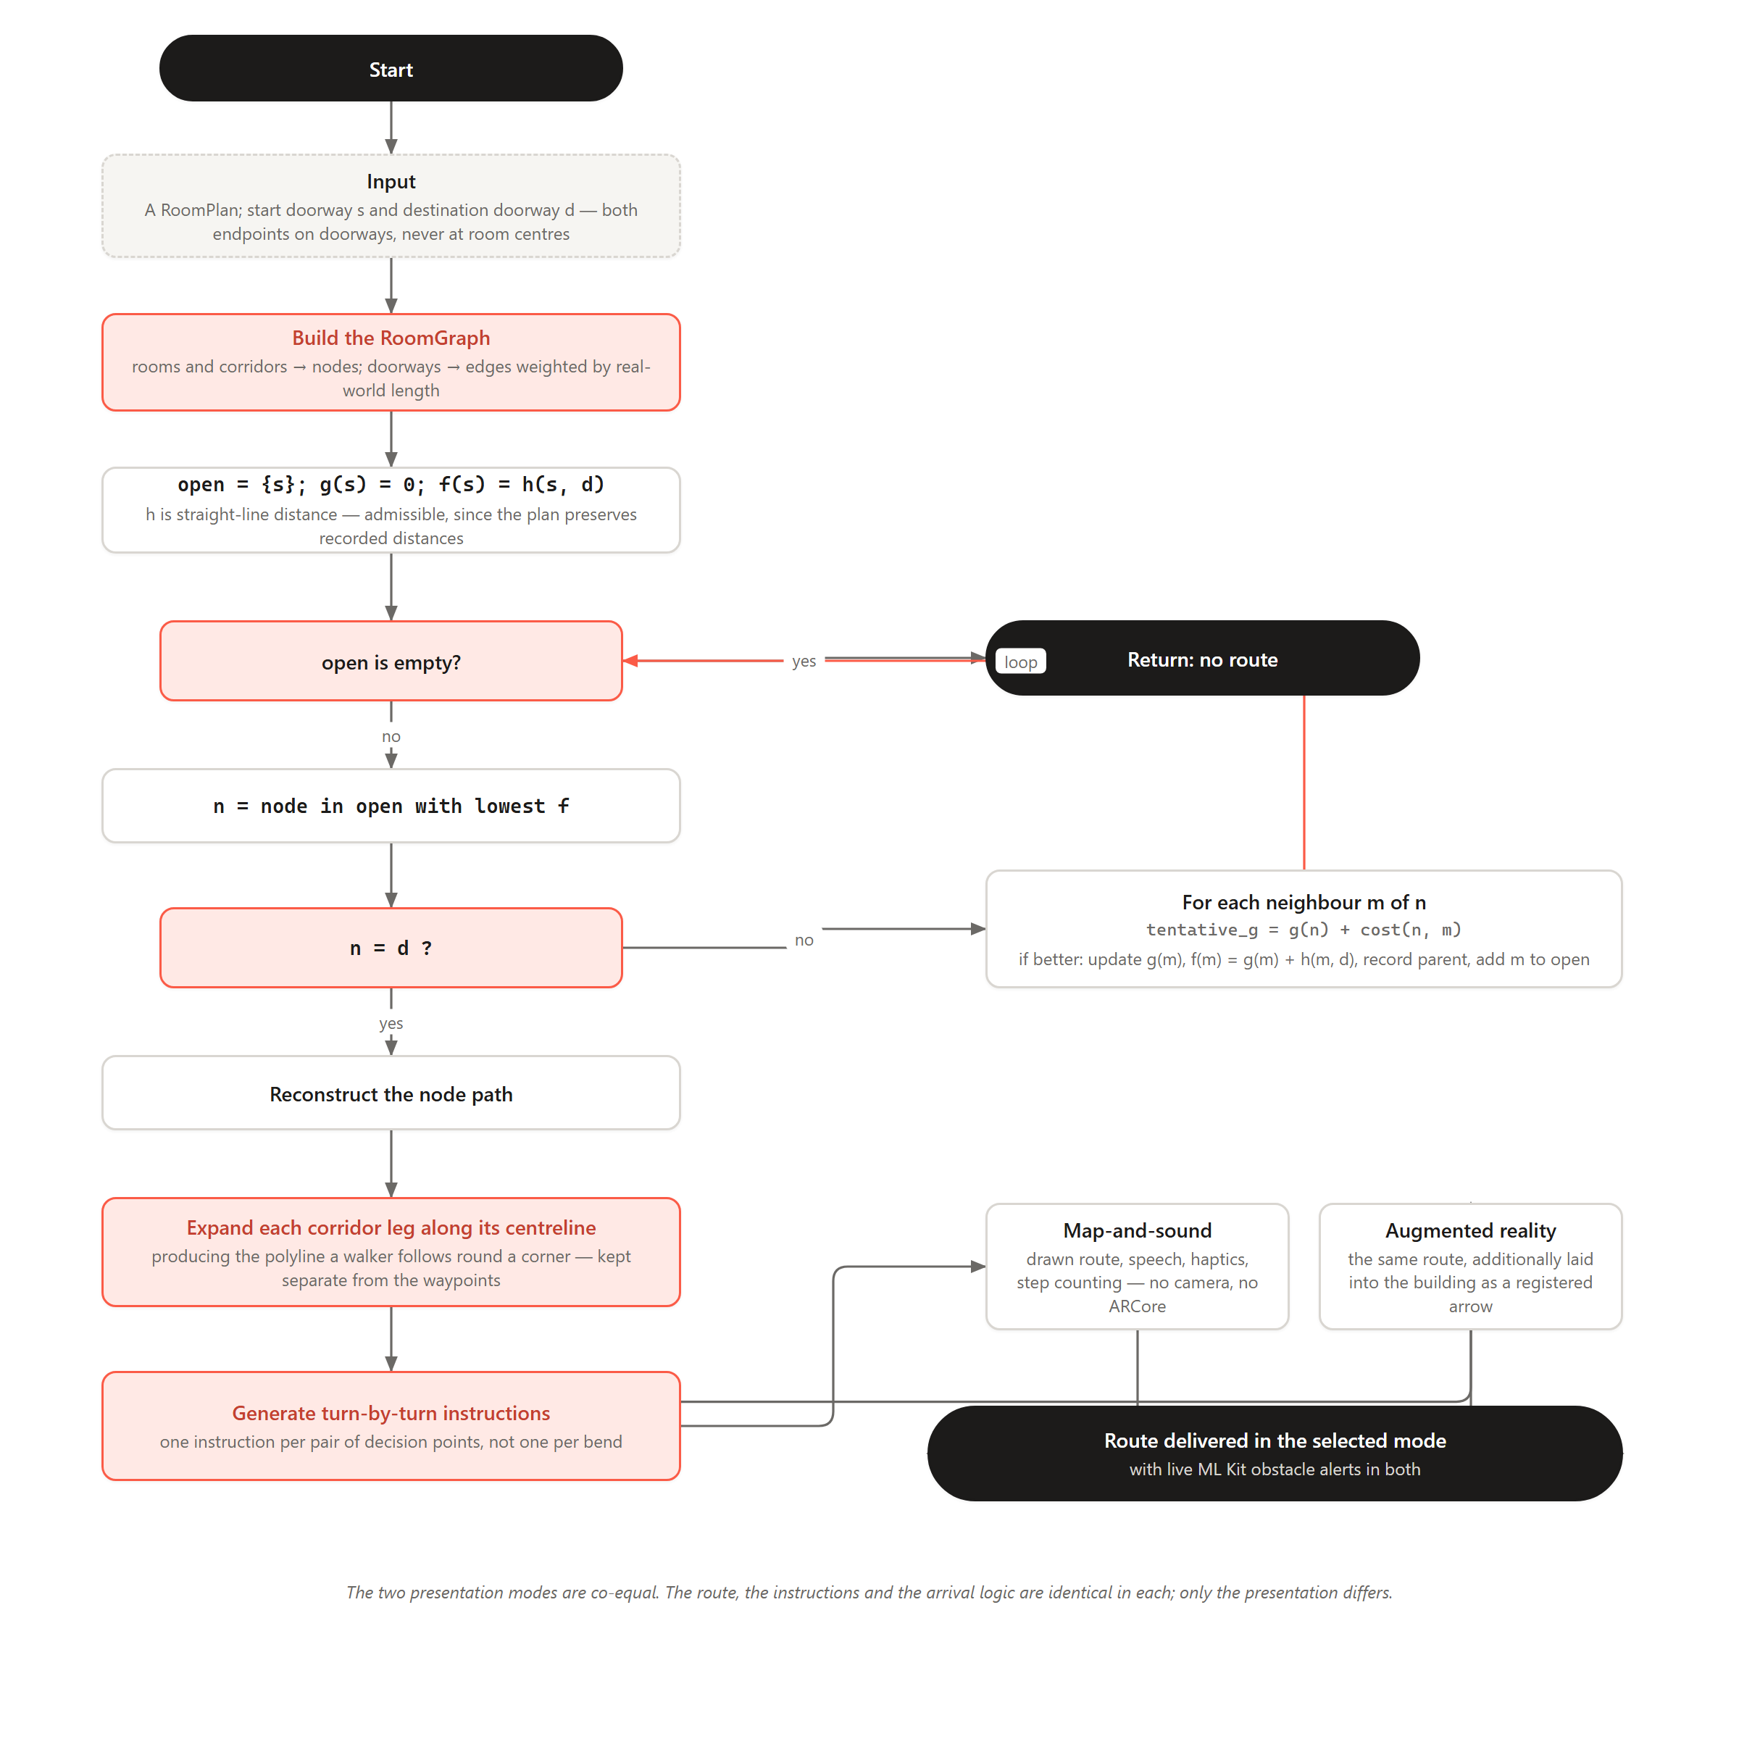
Figure 3.11: Flowchart — A* Indoor Navigation Algorithm

3.11.4 Algorithm 4: Route Registration
The AR arrow described in Algorithm 3 cannot point at a destination unless the planned route is first carried from the plan’s own coordinate frame into the frame ARCore invents at session start. Algorithm 4 solves that transform, and it is what distinguishes a registered route from a floating waypoint marker.
Step | Operation
Input | A planned route in plan coordinates; a live ARCore session; the room the walker has declared themselves to be in.
Step 1 | Take the walker’s ARCore position when guidance starts as their known position on the plan. This fixes the translation.
Step 2 | After a few steps, read the direction of travel from ARCore and the bearing of the route’s first leg from the plan. Assume they coincide; the rotation follows.
Step 3 | Scale is not an unknown: the plan’s metres-per-unit is set by the contributor, so both frames are metric. The transform therefore has three unknowns, and one point plus one direction supplies exactly three constraints.
Step 4 | Correct for handedness: the plan is right-handed read from above, the ARCore floor left-handed.
Step 5 | Apply the transform to lay the whole route into the room at once, with a confidence from the quality of the heading estimate.
Step 6 | On each confirmed landmark, re-solve against that landmark’s known plan position, replacing the heading assumption with a measurement.
Output | A rotation and translation carrying plan coordinates into the ARCore world, with confidence, refreshed at every landmark.
Table 3.13: Algorithm 4 — Route Registration

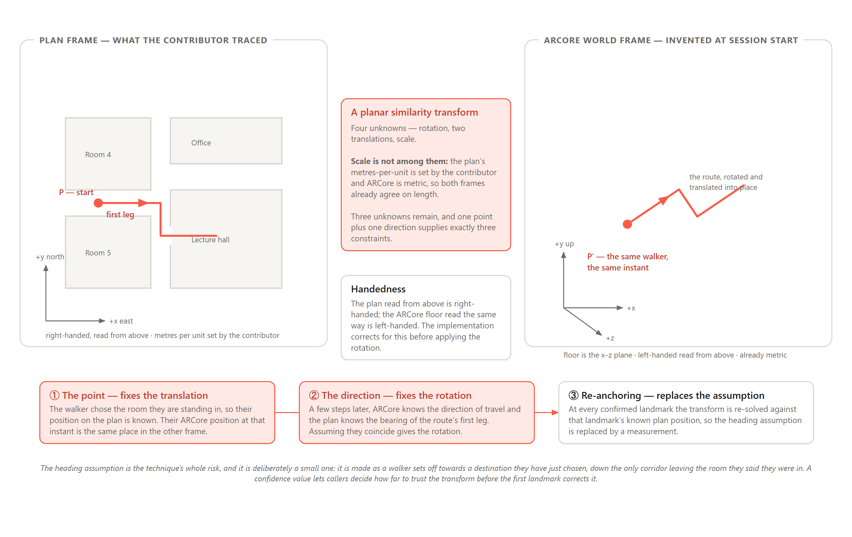
Figure 3.12: Registration Geometry — the Plan Frame, the ARCore World Frame, and the One Point and One Direction that Relate Them

3.12 Project Methods to be Employed
EchoLocate adopts an Agile/Iterative approach. This suits a project carrying significant technical uncertainty across several novel sensing layers — AR route registration, acoustic DSP, semantic detection, accessible navigation — where behaviour on commodity hardware can only be established empirically. Iterations with measurable acceptance gates let deficiencies be corrected before integration and favour continuous benchmarking over feature completeness. It also allowed two proposed sensing approaches to be implemented, evaluated on hardware and replaced by better-evidenced alternatives within the project window.

3.13 Software Process Model
EchoLocate follows an Agile/Iterative Development Model, delivering the system through five weekly-validated phases, each with a defined acceptance gate, over a 12-week timeline.
Phase | Focus | Key Activities | Acceptance Gate
1 | Research and Foundation | Literature review; set up Flutter, ARCore and ML Kit; validate camera capture and chirp emission. | Camera capture and chirp emission demonstrated on a physical device.
2 | Floor-Plan Authoring and Routing | Tracing against a photographed plan; metric scale and geometry cleanup; graph derivation and the Dart A* planner. | A metrically scaled plan authored and a door-to-door route computed over it.
3 | Acoustic DSP and Room Classification | FMCW chirp, FFT pipeline and reverberation features; the rule-based classifier and its fit-quality gate. | Room-type classification operational with rejection of unreliable estimates.
4 | Guidance, AR Registration, Crowdsourcing and Accessibility | Map-and-sound guidance with haptics and step counting; AR registration and arrow; ML Kit detection; Supabase, hive_ce, voice mode and stride calibration. | Feature-complete application build.
5 | Testing and Refinement | Map-accuracy, acoustic-accuracy and navigation success-rate testing; performance profiling; finalise report. | Validated, deployable build meeting accuracy and usability targets.
Table 3.14: EchoLocate Iterative Development Plan
This model was chosen because the sensing layers carry uncertainty that must be retired empirically, unlike Waterfall, whose upfront design assumes stable requirements. Validating each modality at its gate before integration reduces compounding failures and keeps a limited timeline focused on the highest-risk components.

3.14 Project Design Considerations (Logical Designs)

3.14.1 User Interface Design
The interface follows an accessibility-first, high-contrast design language built on a single warm accent — coral #FB5B47 — against near-black ink (#1C1B1A) and an off-white surface (#F6F5F2), set in Lexend, a typeface designed around reading-fluency research. Touch targets are large, iconography plain, and every colour-coded status carries a text label, so guidance is never conveyed by colour alone. Each screen is defined in light and dark from one token set. Figures 3.13–3.24 present the principal screens as wireframes, drawn from the delivered application, so the layouts shown are the ones that were built.
  Figure 3.13: Welcome / Landing |   Figure 3.14: Create Account |   Figure 3.15: Sign In
  Figure 3.16: Home — “Where to?” |   Figure 3.17: Explore Buildings |   Figure 3.18: Maps — the Offline Library
  Figure 3.19: Profile and Contribution Counts |   Figure 3.20: Tracing a Floor Plan |   Figure 3.21: Route Preview and Turn-by-Turn Steps
  Figure 3.22: Map-and-Sound Guidance |   Figure 3.23: Augmented-Reality Guidance |   Figure 3.24: Assistance — Obstacle Alerts and Sign Reading
Figures 3.13–3.24: EchoLocate User-Interface Wireframes

3.14.2 Database Design
EchoLocate uses a local-first hive_ce store on-device, with a Supabase (PostgreSQL) tier holding published copies of shared plans. Locally, plans and their unpublished drafts sit under separate key prefixes so an incomplete trace can never overwrite the plan it is a draft of, and repository queries are cached to keep browsing usable offline. The cloud side is defined across fourteen migrations under supabase/migrations/ and is presented below as the conceptual entity-relationship model and the relational schema derived from it. Foreign keys from a building or floor cascade on delete, so removing a building removes its plans, landmarks and routes with it.

(i) Entity-Relationship Diagram
Figure 3.25 presents the conceptual model in Chen notation: rectangles are entities, ellipses their attributes with primary keys underlined, and diamonds the relationships, each leg marked with its cardinality. ROOM_PLAN and ROUTE_STEP are weak entities because neither is identified on its own — a plan is identified by its building, a step by its route and position in it. The two many-to-many relationships, contributes and saves, are what the junction tables below implement; contributes carries attributes of its own, since how many floors and rooms a contributor mapped is a property of the pairing rather than of either side.
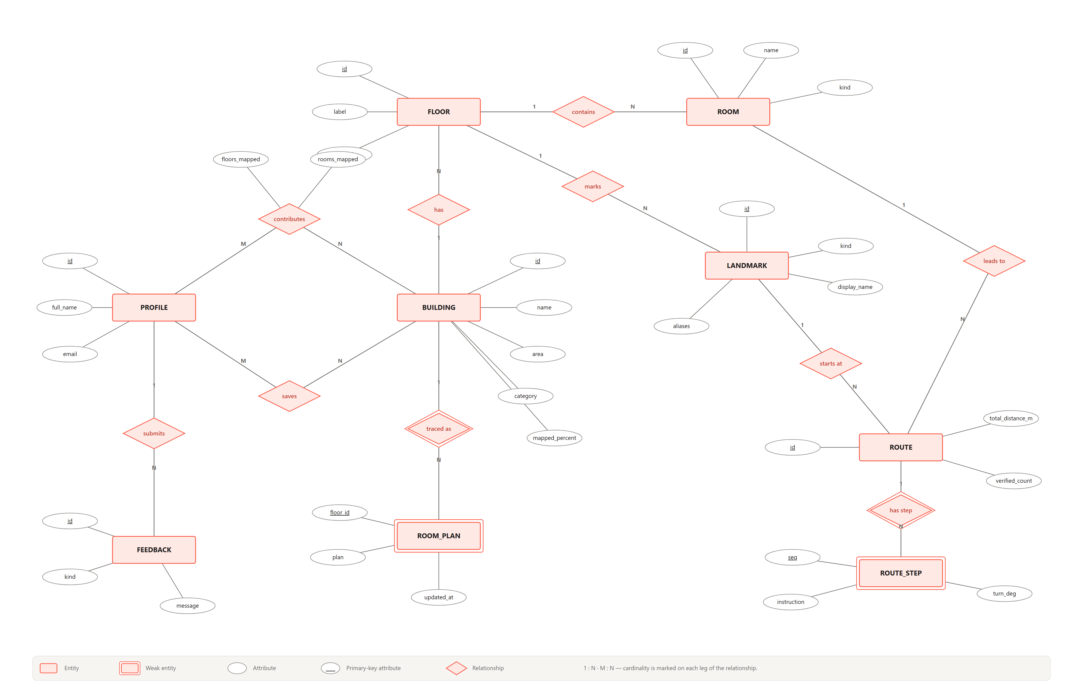
Figure 3.25: Entity-Relationship Diagram — EchoLocate Database

(ii) Database Schema
The relational schema in Figure 3.26 shows each of the twelve tables as a row of attribute boxes. Underlined fields are primary keys — several tables are keyed on a composite, such as room_plans on (building_id, floor_id) and route_steps on (route_id, seq) — and italic fields are foreign keys, each arrow pointing to the primary key it references. Where the entity-relationship diagram models nine conceptual entities, the schema shows every table that exists, including traced_plans, which stores the photographed backdrop a plan was traced over, and the junction tables building_contributors and saved_maps.
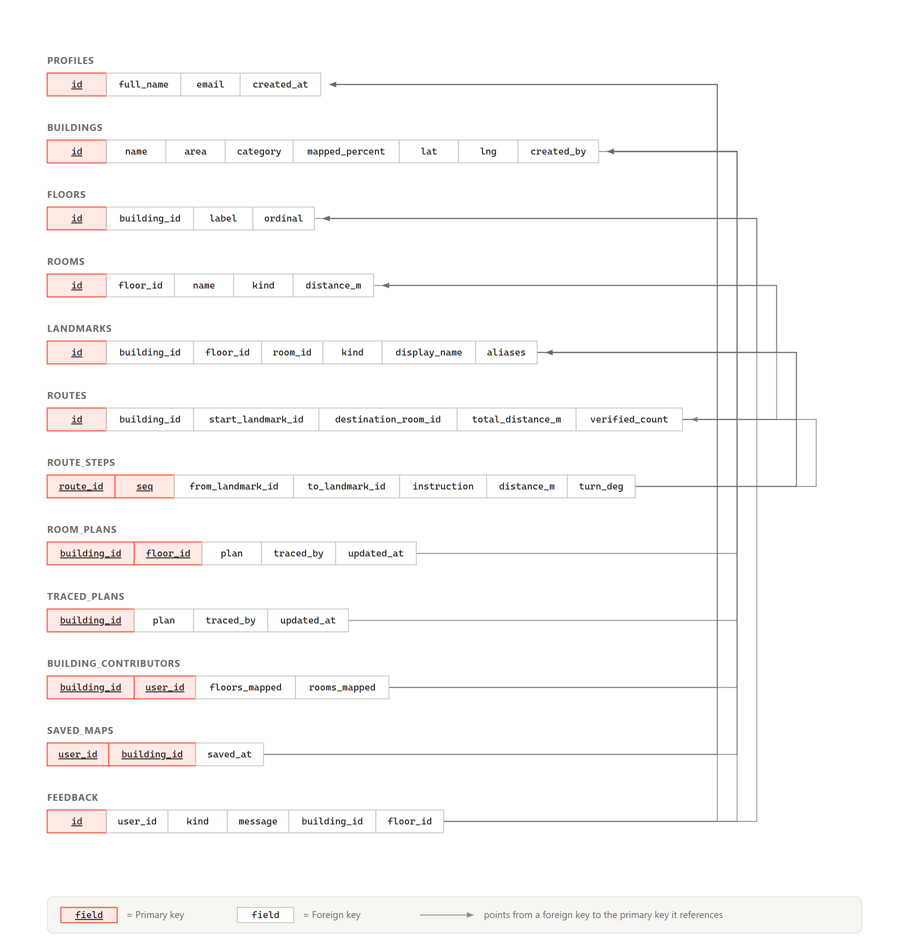
Figure 3.26: Database Schema — EchoLocate Supabase Tables

3.15 Development Tools
Table 3.15 summarises the primary development tools and technologies, with their role in the methodology described in this chapter.
Tool / Technology | Role in EchoLocate
Flutter (Dart) | Primary cross-platform framework; provides a single codebase for the application, all user-interface screens, and core application logic.
flutter_bloc | Presentation-layer state; each screen owns a Bloc or Cubit exposing loading, error and data states to the widget tree.
ARCore (custom platform channel) | Motion tracking and world-frame pose for the AR waypoint overlay and route registration, reached from Flutter through a native Android platform channel.
Google ML Kit | On-device computer vision: object detection for obstacle alerts and text recognition of room numbers and signage during navigation, with no cloud processing.
fftea | Fast Fourier Transform over captured audio, supporting reverberation feature extraction — the project’s Digital Signal Processing component.
flutter_soloud / record | Chirp emission through the device speaker and synchronised capture of the returning signal.
pedometer / sensors_plus | Hardware step counting for distance estimation along a route leg, with stride length calibrated per user.
A* Routing Engine (custom Dart) | Computes the shortest navigable path through the graph derived from a traced floor plan, driving turn-by-turn navigation.
hive_ce | Local-first on-device store holding authored plans, drafts and cached repository queries, keeping the application usable offline.
Supabase | Cloud backend for the crowdsourced map repository; stores and serves community-published floor plans and contributor records.
flutter_tts & speech_to_text | Voice interface; delivers spoken turn-by-turn guidance and accepts voice commands for the accessibility mode.
Table 3.15: EchoLocate Development Tools

CHAPTER FOUR: IMPLEMENTATION, TESTING, AND RESULTS

4.1 Implementation

4.1.1 Introduction
Chapter Three specified EchoLocate’s architecture, components and algorithms. This chapter reports how that specification was realised, how the result was verified and what it achieves. Where the delivered system departs from the specification, the departure and its reason are stated: the chapter describes what was built, not what was proposed.
The delivered system comprises 40,389 lines of Dart across 179 files, 4,749 lines of Kotlin implementing the native augmented-reality layer, and 18,258 lines of automated test code covering 927 test cases across 64 test files. The application presents 24 screens, each implemented in both light and dark themes.
Three conventions were held throughout, because a multimodal system accumulates coupling quickly without them. Repositories return typed models rather than untyped maps, each domain exposing an abstract interface with interchangeable on-device and cloud implementations. Blocs own screen state while services own hardware — sensing services are singletons that Blocs subscribe to, rather than each screen opening the camera itself, which matters because ARCore holds the camera exclusively. And every screen is built in light and dark from a shared token set, so none carries a hard-coded colour.
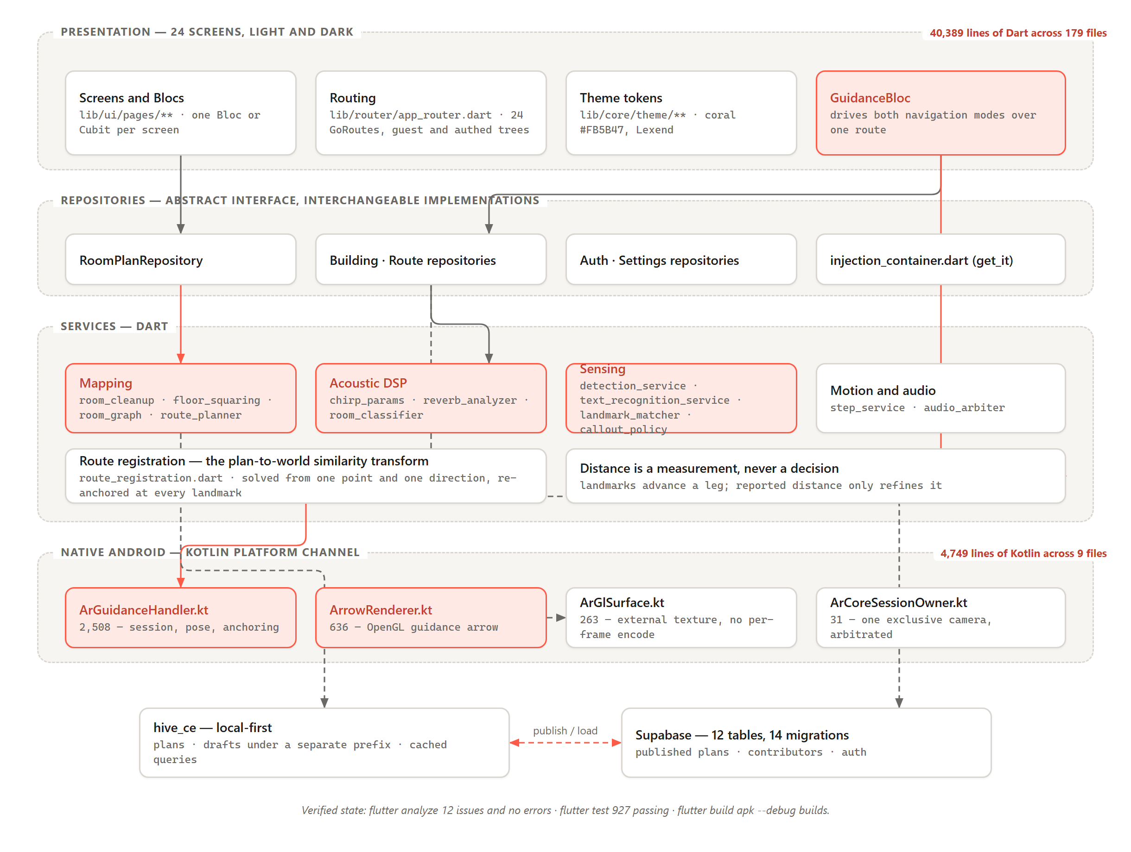
Figure 4.1: Implemented Layered Architecture of EchoLocate

4.1.2 Implementation of the Frontend
The interface follows a five-destination bottom navigation pattern — Home, Explore, a centre action, Maps, Profile — with full-screen flows pushed above it. Twenty-four screens were implemented, grouped as in Table 4.1.
Group | Screens
Onboarding and authentication | onboarding, welcome, sign in, sign up, camera primer, location primer
Browsing | home, explore, maps
Authoring | map building, building mapping hub, plan trace, room trace, plan editor
Navigation | navigate, room navigate, guidance
Sensing | assist, acoustic, sonar, depth probe, room plan probe
Profile | profile, stride calibration
Table 4.1: Implemented Screens by Functional Group
The visual system uses one warm accent (coral #FB5B47) against near-black ink and an off-white surface, set in Lexend, with rounded cards and soft shadows. Every colour and spacing value comes from a token file rather than the point of use, which makes the dark theme a redefinition of tokens rather than a second set of screens.
Permission priming is handled by dedicated primer screens shown once before the first camera or location request, rather than by raising a system dialogue cold. A user who denies a permission unexpectedly is expensive to recover.
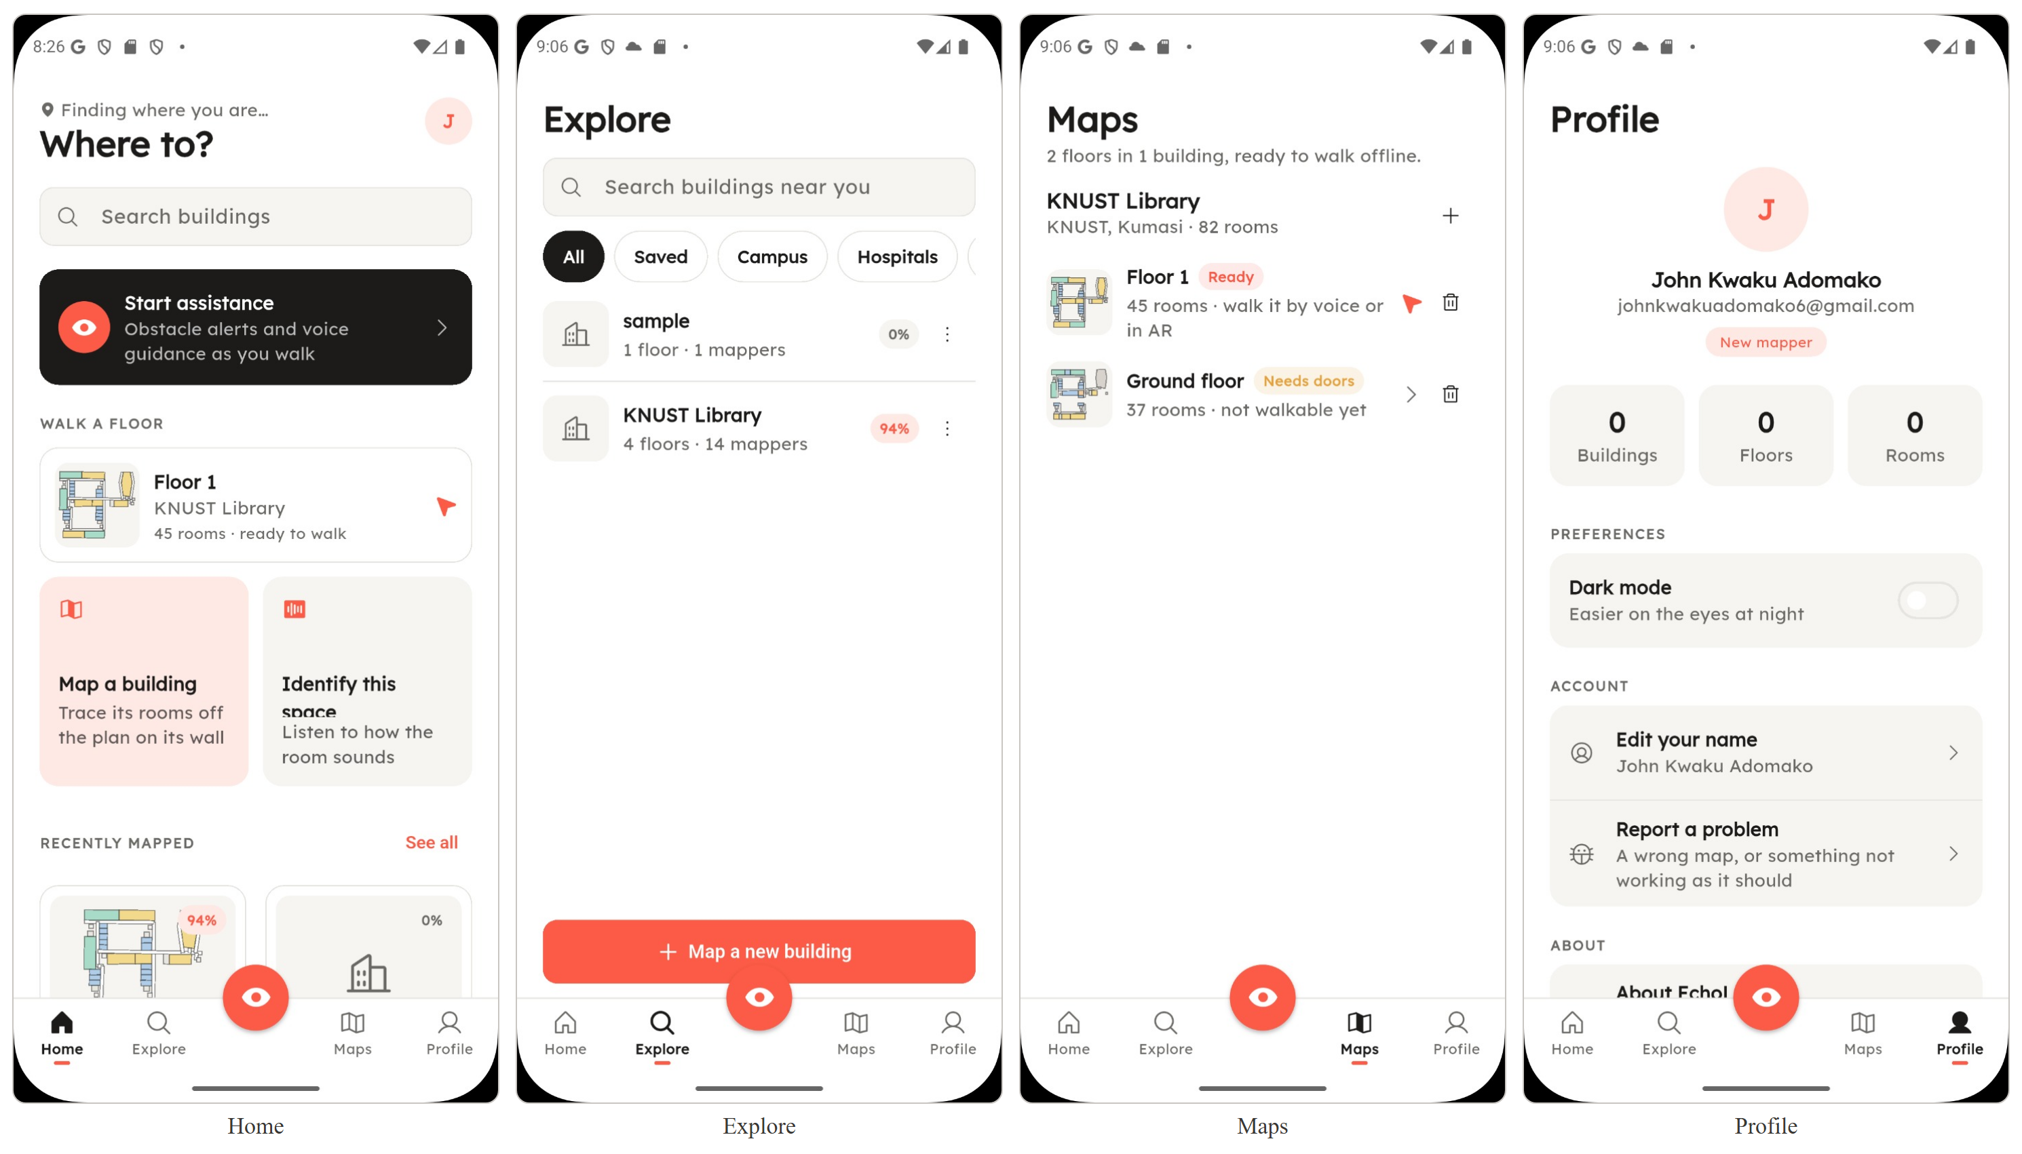
Figure 4.2: Principal Application Screens — Home, Explore, Maps and Profile
Each screen owns a Bloc or Cubit and renders from its state. The listing below, from lib/ui/pages/explore/explore_page.dart, is representative: a BlocBuilder rebuilds on state change, actions are dispatched as events, and every branch of the state — loading, failure, data — is rendered explicitly.
Expanded(
child: BlocBuilder<ExploreBloc, ExploreState>(
builder: (context, state) => switch (state.status) {
ExploreStatus.initial || ExploreStatus.loading =>
const Center(child: CircularProgressIndicator()),
ExploreStatus.failure => Center(
child: Text(
state.error ?? 'Could not load buildings',
style: theme.textTheme.bodyMedium,
),
),
ExploreStatus.success => ListView.builder(...),
},
),
),
Filter interaction dispatches an event rather than mutating local widget state, and buildWhen restricts rebuilds to the field that actually changed.
BlocBuilder<ExploreBloc, ExploreState>(
buildWhen: (a, b) => a.category != b.category,
builder: (context, state) => ... _FilterChip(
label: label,
selected: state.category == id,
onTap: () => context.read<ExploreBloc>().add(ExploreCategoryChanged(id)),
),
),

4.1.3 Implementation of the Backend
The backend is local-first: everything works offline against an on-device hive_ce store, and published plans synchronise with a Supabase (PostgreSQL) tier.
The cloud schema is defined across fourteen migrations under supabase/migrations/, normalised around buildings and its dependent floors and rooms, with room_plans holding traced polygon geometry per floor, traced_plans the photographed backdrop a plan was traced over, landmarks the confirmable features placed on it, routes and route_steps for recorded walks, profiles and building_contributors for attribution, saved_maps for a user’s library, and feedback for in-app reports. Foreign keys with cascade deletion keep a plan and its dependent rows consistent. The schema is shown in Figure 3.26.
Three design decisions are worth reporting. Drafts are isolated from published plans by key prefix: until publication a plan exists only in memory, so a draft is written on every structural change under a prefix that makes overwriting the published plan impossible. Plans are stored as encoded JSON strings rather than maps, because the nested lists of immutable models within a plan are not types the local store recognises and it fails at the moment of saving; encoding once at the boundary makes that failure impossible rather than intermittent. Plan replacement is last-write-wins by design: two contributors tracing the same floor produce two opinions of the same geometry, and merging polygons cannot be done sensibly without asking a person which is right.
Storage is reached through an abstract interface, so the on-device and Supabase implementations are interchangeable. From lib/features/room_trace/room_plan_repository.dart:
abstract class RoomPlanRepository {
/// The traced rooms for one floor, or null when nobody has traced it.
Future<RoomPlan?> planFor(String buildingId, String floorId);
/// Every floor of a building that has been traced.
Future<List<RoomPlan>> plansOf(String buildingId);
/// Stores a plan, replacing whatever that floor had.
Future<void> save(RoomPlan plan);
Future<void> delete(String buildingId, String floorId);
/// Keeps the floor as it stands right now, without publishing it.
/// Always device-local: a draft is by definition work somebody has
/// not chosen to share.
Future<void> saveDraft(RoomPlan plan);
Future<RoomPlan?> draftFor(String buildingId, String floorId);
Future<void> clearDraft(String buildingId, String floorId);
}
Implementations are selected once at startup, in lib/services/injection_container.dart, so no screen knows which is in use.
getIt.registerLazySingleton<RoomPlanRepository>(
() => AppConfig.hasSupabase
? SupabaseRoomPlanRepository(Supabase.instance.client)
: const LocalRoomPlanRepository(),
);

4.1.4 The Login Module
Authentication is provided by Supabase, with native Google sign-in through Android’s Credential Manager yielding an ID token that Supabase exchanges for a session.
The module comprises AuthRepository (abstract), SupabaseAuthRepository (production) and MockAuthRepository (used when no Supabase configuration is present). AuthBloc holds session state for the application, and the router listens to it, redirecting between a guest route tree and the authenticated tree whenever the Bloc emits.
String? _redirect(BuildContext context, GoRouterState state) {
final settings = getIt<SettingsRepository>();
final authenticated = getIt<AuthBloc>().state is AuthAuthenticated;
final onGuestPath = _guestPaths.contains(state.matchedLocation);
if (!settings.onboardingSeen) { ... return AppRoutes.onboarding; }
if (!authenticated) {
if (onGuestPath && location != AppRoutes.onboarding) return null;
return AppRoutes.welcome;
}
if (onGuestPath) return AppRoutes.home;
return null;
}
Network and credential failures are translated into readable messages at the repository boundary rather than surfaced as exceptions, behaviour covered by supabase_auth_repository_test.dart.
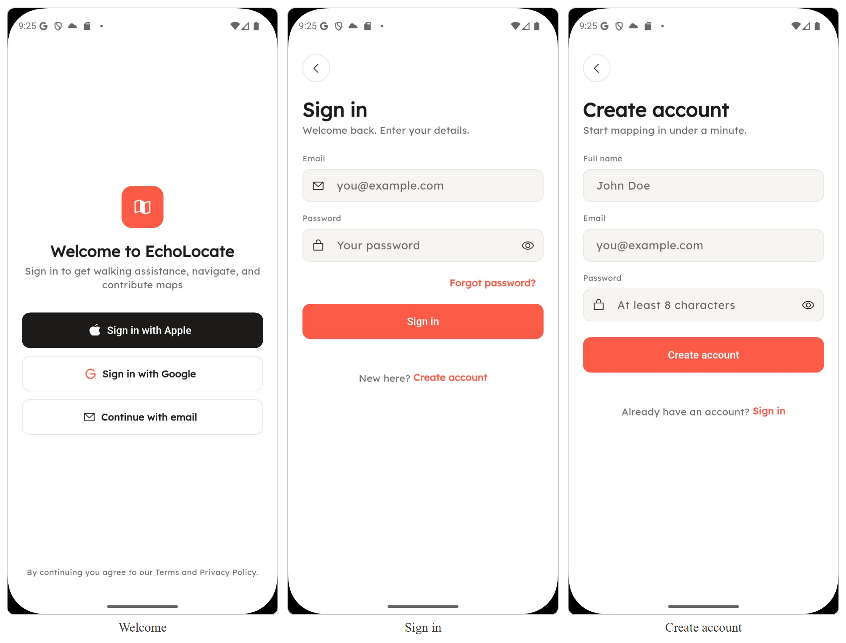
Figure 4.3: Welcome, Sign-In and Create-Account Screens

4.1.5 The Floor-Plan Authoring Module
This module replaces the depth-based plan generation named in the original proposal; §3.11.1 was revised to specify tracing instead. Tracing produces a metrically scaled floor in about twenty minutes, depends on no tracking quality, and works on every Android phone rather than only ARCore-certified ones — so contributing is open to everyone.
A contributor produces a floor plan by photographing a posted plan, or tracing the space directly, and laying down closed polygons for rooms and corridors. Corners are captured in plan coordinates with +x east and +y north; a metric scale is established by marking one known real-world distance.
Traced geometry is cleaned rather than trusted (room_cleanup.dart, floor_squaring.dart): near-coincident corners merged, near-orthogonal walls squared, degenerate polygons discarded. Room types come from a short wall-board vocabulary rather than a building-code classification, because a contributor chooses one while standing in a corridor and every entry must be identifiable from a doorway.
Because a large building cannot be traced in one sitting, a floor is authored a wing at a time and wings are reconciled by dragging one into place against another — human-in-the-loop alignment in place of pose-graph optimisation, on the grounds that the latter is weeks of work and the former is a contributor who can see the building.
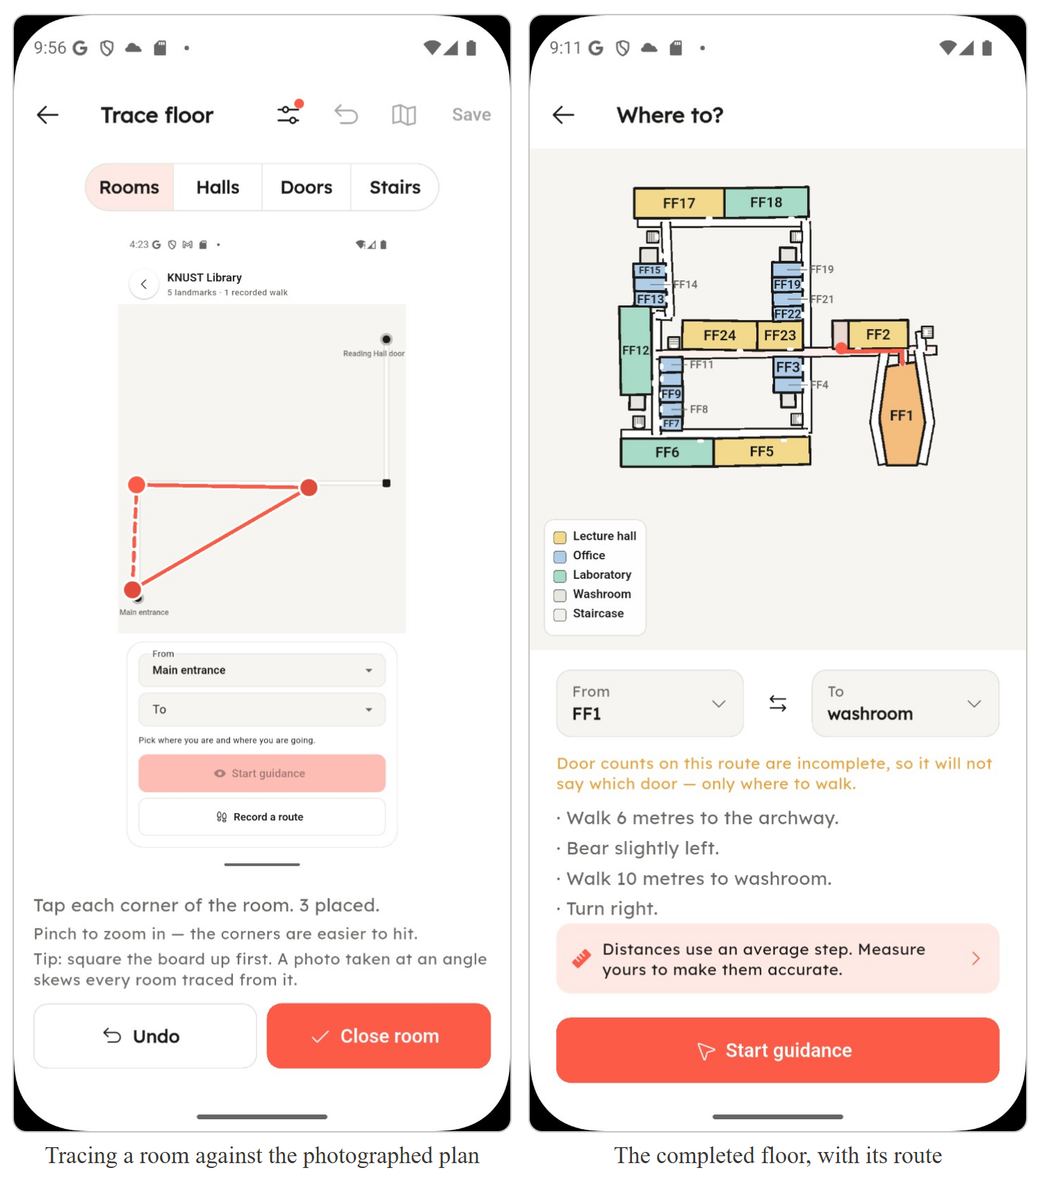
Figure 4.4: Floor-Plan Authoring — Tracing a Room, and the Completed Floor

4.1.6 Implementation of the Graph Derivation and Routing Method
Traced geometry is converted into a navigable graph in which rooms and corridors are nodes and doorways weighted edges (room_graph.dart). Routes are computed by a custom Dart A* implementation (route_planner.dart) using a straight-line Euclidean heuristic, admissible because the layout preserves recorded distances.
final open = <String>[from];
final costSoFar = <String, double>{from: 0};
while (open.isNotEmpty) {
// A list scan rather than a heap: a floor holds tens of landmarks, and
// the constant factor of a priority queue is not worth the code.
final current = _lowestEstimate(open, costSoFar, graph, to);
if (current == to) return _reconstruct(graph, cameFrom, from, to, landmarks, recorded);
for (final neighbour in graph.neighboursOf(current)) {
final cost = costSoFar[current]! + neighbour.distanceM;
final known = costSoFar[neighbour.landmarkId];
if (known != null && known <= cost) continue;
costSoFar[neighbour.landmarkId] = cost;
cameFrom[neighbour.landmarkId] = Neighbour(landmarkId: current, edge: neighbour.edge);
if (!open.contains(neighbour.landmarkId)) open.add(neighbour.landmarkId);
}
}
return null;
Two details distinguish the implementation from the textbook algorithm. Both endpoints sit on doorways rather than room centres: a route between room centres begins and ends in open floor with no door in sight, so endpoints were moved onto the doorway while retaining the room they belong to, and the final spoken instruction still names the room. Waypoints and the drawn polyline are also deliberately separate — waypoints are decision points producing one instruction per pair, while the polyline expands each corridor leg along its centreline so the route follows the hallway round a corner. Merging them would generate an instruction for every bend.
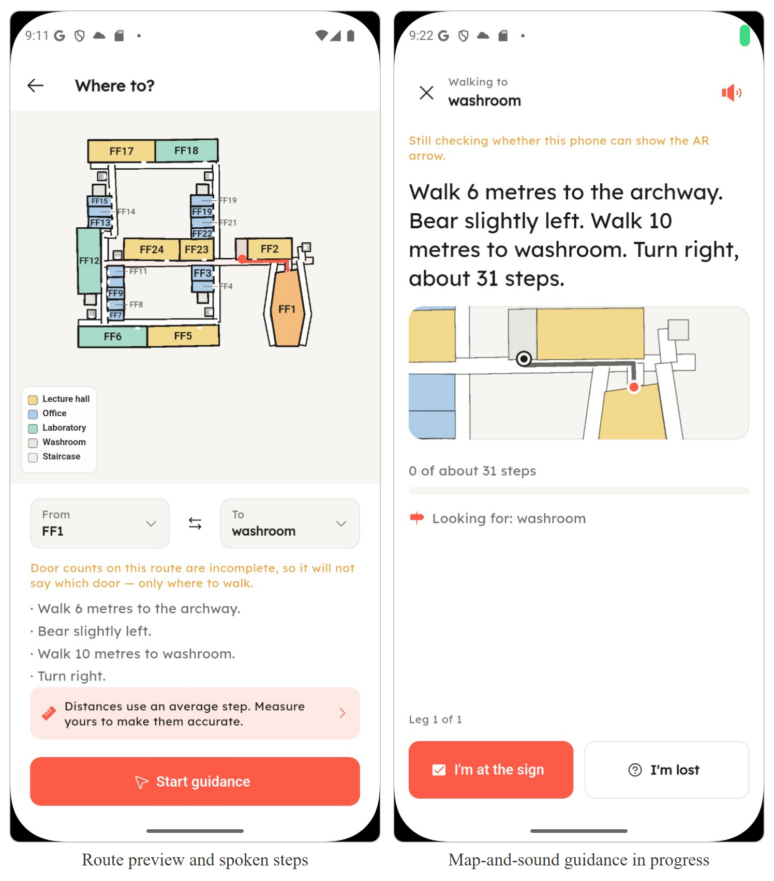
Figure 4.5: A Planned Route Drawn over a Traced Floor, and Guidance in Progress

4.1.7 Implementation of the Augmented-Reality Route Registration Technique
This is the most substantial component of the system, corresponding to Algorithm 4 in §3.11.4. It was built because the waypoint arrow specified in Chapter Three could not work without it.
The problem is one of coordinate frames. Plan geometry uses the plan’s own frame: +x east, +y north, origin wherever tracing began. ARCore uses a frame it invents at session start, +y up, floor in the x–z plane. Guidance originally bridged the two by refusing to, walking a chain of relative turns each measured from the last. That is why the arrow could not navigate: such a chain is only as good as the direction its first link was hung from, and that was whichever way the phone happened to be pointing.
The solution rests on the transform’s degrees of freedom. A planar similarity transform has four unknowns, but scale is not among them here — the plan’s metres-per-unit is set by the contributor, so both frames are already metric. That leaves three, which is exactly what one point plus one direction supplies. The point is the walker’s position on the plan, known when guidance starts because they chose the room they are in; their ARCore position at that instant is the same place in the other frame. The direction comes a few steps later, when ARCore knows the direction of travel and the plan knows the bearing of the first leg. The implementation also corrects for handedness: the plan is right-handed read from above, the ARCore floor left-handed.
The heading assumption is the technique’s whole risk, and deliberately a small one: it is made as a walker sets off toward a destination they have just chosen, down the only corridor leaving the room they said they were in. A confidence value lets callers decide whether to trust the transform, and re-registration at each confirmed landmark replaces the assumption with a measurement.
A second mechanism reduces residual error. Because corridors are rectilinear, the route’s legs imply a grid. Leg bearings are summed as unit vectors at four times their bearing, weighted by length — quadrupling makes legs at 0°, 90°, 180° and 270° reinforce rather than cancel, whereas averaging bearings directly would place a corridor and the one crossing it at 45°, the one answer that cannot be right. Measured yaw selects the quarter turn; the grid supplies the value.
for (var i = 0; i + 1 < path.length; i++) {
final delta = path[i + 1] - path[i];
final length = delta.distance;
if (length < minLegM) continue; // short legs do not vote
final quadrupled = 4 * planBearingOf(delta);
sumSin += length * math.sin(quadrupled);
sumCos += length * math.cos(quadrupled);
weight += length;
}
if (weight <= 0) return null;
final resultant = math.sqrt(sumSin * sumSin + sumCos * sumCos) / weight;
if (spreadOfResultant(resultant) > maxSpreadRad) return null;
return foldToQuarter(math.atan2(sumSin, sumCos) / 4);
ARCore integration was written directly rather than taken from a plugin, comprising 4,749 lines of Kotlin across nine main-source files, distributed as shown in Table 4.2.
File | Lines | Role
ArGuidanceHandler.kt | 2,508 | Session lifecycle, pose streaming, route anchoring
ArrowRenderer.kt | 636 | OpenGL rendering of the guidance arrow
ArCoreDepthHandler.kt | 453 | Depth API access and availability checks
RegisteredRoute.kt | 358 | The route as laid into the world frame
ArGlSurface.kt | 263 | External-texture surface shared with Flutter
CameraBackgroundRenderer.kt | 239 | Camera feed as the AR background
AnalysisFraming.kt | 193 | Camera-configuration choice for the ML Kit analysis stream
MainActivity.kt | 68 | Platform-channel registration
ArCoreSessionOwner.kt | 31 | Arbitrates the exclusive ARCore camera between screens
Table 4.2: Native Augmented-Reality Layer — Kotlin Source Files
A significant performance decision sits in ArGlSurface.kt: the camera preview reaches Flutter as an external texture rather than as encoded frames, removing a per-frame encode/decode round trip from the render path.
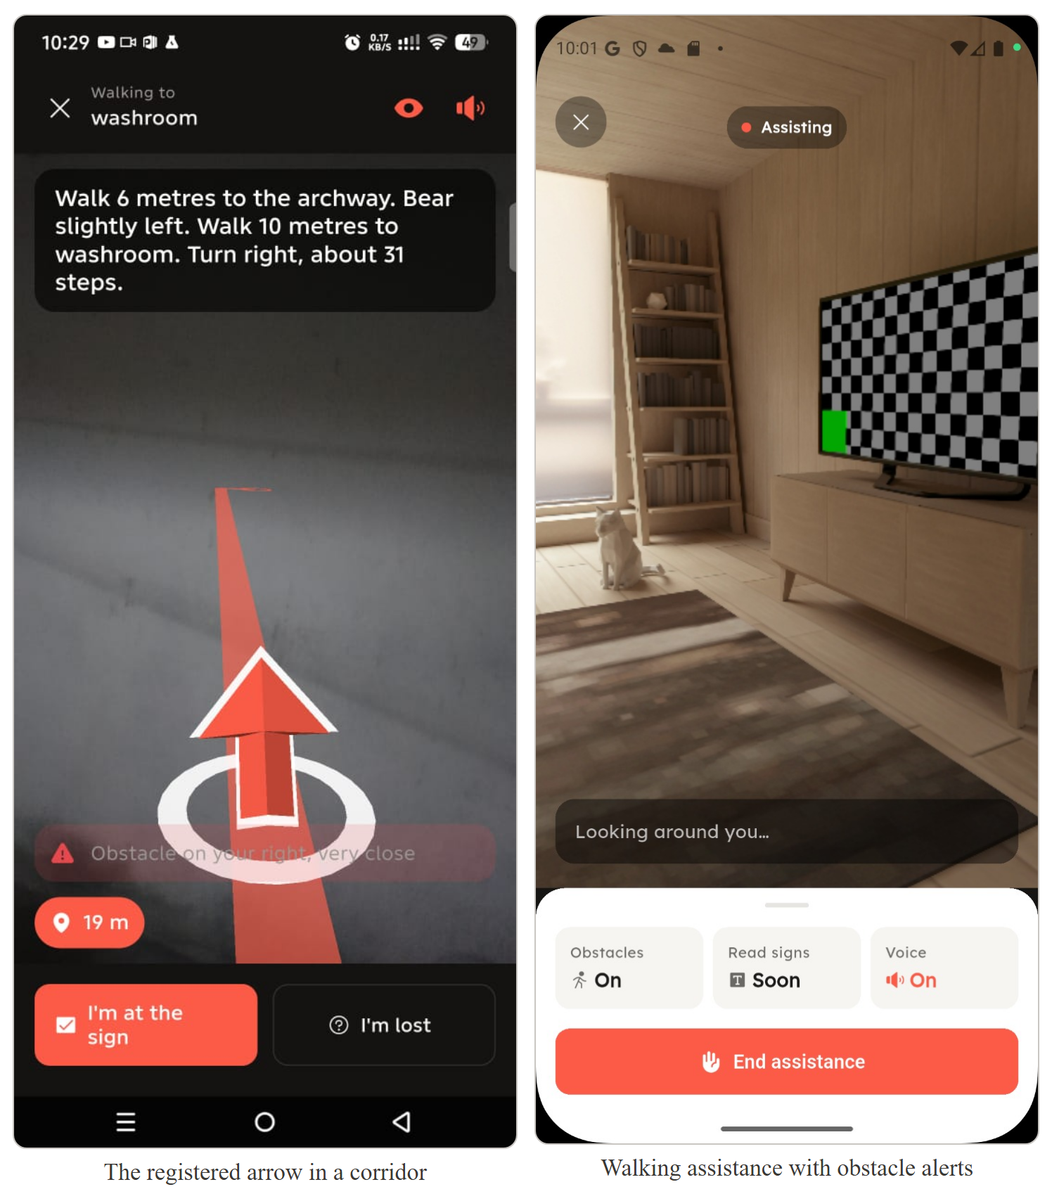
Figure 4.6: The Augmented-Reality Guidance Arrow, and Walking Assistance

4.1.8 Implementation of the Semantic Detection Module
Google ML Kit object detection and text recognition run against the live camera feed to raise obstacle alerts and read room numbers and signage aloud (detection_service.dart, text_recognition_service.dart). Both run on-device; no image leaves the phone.
The service resolves its frame source at start, preferring an already-streaming AR session, since ARCore holds the camera exclusively. Recognised text is matched against known landmarks by landmark_matcher.dart, which tightens the edit-distance tolerance originally specified: room codes differ by single characters, and a tolerant match confidently reports the wrong room. What is announced, and how often, is separated into callout_policy.dart so it can be tuned without touching detection.

4.1.9 Implementation of the Acoustic Digital Signal Processing Pipeline
The pipeline emits a linear FMCW up-sweep and analyses the return to characterise the space. This is the project’s Digital Signal Processing contribution.
The signal parameters implemented in chirp_params.dart — a 13–19 kHz linear up-sweep of 120 ms at 44.1 kHz — are the values specified in §3.11.2, not those first proposed: band and sweep duration were both changed during implementation, deliberately and toward better performance, and §3.11.2 was revised to match. Table 4.3 records the change and its reason. The change was assessed for its effect on the ambient noise floor; its effect on the dynamic range above that floor, on which reverberation measurement depends, was not assessed at the time, and §4.3.6 reports the consequence.
Parameter | First proposed | Implemented (and specified in §3.11.2) | Reason
Band | 2–8 kHz | 13–19 kHz | Speech, footsteps and HVAC put almost all energy below ~8 kHz. Above that band ambient noise contributes little to the correlation, so the noise floor falls in a crowded room rather than rising. The band is also faint or inaudible to most listeners. Bandwidth is unchanged at 6 kHz, so range resolution is unaffected.
Duration | 40 ms | 120 ms | Matched-filter gain follows the time–bandwidth product. At 6 kHz, 40 ms gives TB = 240 (≈ 24 dB); 120 ms gives TB = 720 (≈ 28.6 dB). The compressed pulse stays equally sharp, its width set by bandwidth, not duration.
Sample rate | 44.1 kHz | 44.1 kHz | Unchanged; keeps the band below Nyquist with margin for microphone roll-off.
Table 4.3: FMCW Signal Parameters as First Proposed and as Implemented
Feature extraction (reverb_analyzer.dart) derives four quantities from the energy decay curve: RT60, extrapolated from a reliable portion of the decay rather than a full 60 dB; early decay time, the same slope over the first 10 dB; fit quality r², since a real decay in dB is close to linear and a low value means noise was measured; and usable decay range, because an RT60 extrapolated from 8 dB is a weaker claim than one from 25 dB. The last two act as a gate, rejecting an estimate rather than classifying it.
Classification (room_classifier.dart) applies interpretable rules. The EDT/RT60 ratio is the key discriminator: in a diffuse room energy arrives from all directions and decays at one rate throughout, so early and late decay agree; in a corridor, strong parallel reflections make early decay much shorter. That ratio separates corridors from rooms in a way neither value achieves alone.
final rt60 = features.rt60Seconds;
final ratio = rt60 <= 0 ? 1.0 : features.earlyDecayTimeSeconds / rt60;

// Decay SHAPE is tested first. A corridor can share an RT60 with a room,
// so duration alone cannot separate them; a markedly non-diffuse decay
// can only come from strongly directional geometry.
if (rt60 >= minCorridorRt60 && ratio < maxDiffuseRatio) {
return RoomClassification(
type: RoomType.corridor,
confidence: _confidence(maxDiffuseRatio - ratio, maxDiffuseRatio),
features: features,
reason: 'non-diffuse decay (EDT/RT60 ${ratio.toStringAsFixed(2)}) - '
'strong early reflections off parallel surfaces',
);
}
if (rt60 <= smallRoomMaxRt60) { /* small room */ }
The thresholds are given in Table 4.4. Each is a constructor parameter rather than a constant, so the evaluation in §4.3.5 can re-fit them against measured rooms.
Threshold | Value | Meaning
smallRoomMaxRt60 | 0.6 s | At or below, a small, well-absorbing space
hallMinRt60 | 1.2 s | At or above, a large, lightly absorbing volume
maxDiffuseRatio | 0.8 | Below, the field is non-diffuse — a corridor
minCorridorRt60 | 0.4 s | Floor below which a corridor reading is not believed
Table 4.4: Room-Classification Thresholds
The original proposal specified a TensorFlow Lite classifier; rules were implemented instead and §3.11.2 revised accordingly. The choice is argued rather than conceded: Sabine’s relation ties reverberation time to volume and absorption, so classes separate along RT60 for physical reasons and every decision can be defended from room acoustics. A network trained on the few samples obtainable in twelve weeks carries unquantified generalisation risk for little additional separation. Every classification also returns a reason string, so a wrong answer can be diagnosed rather than merely observed, and the interface is unchanged, so a learned classifier can replace it later.
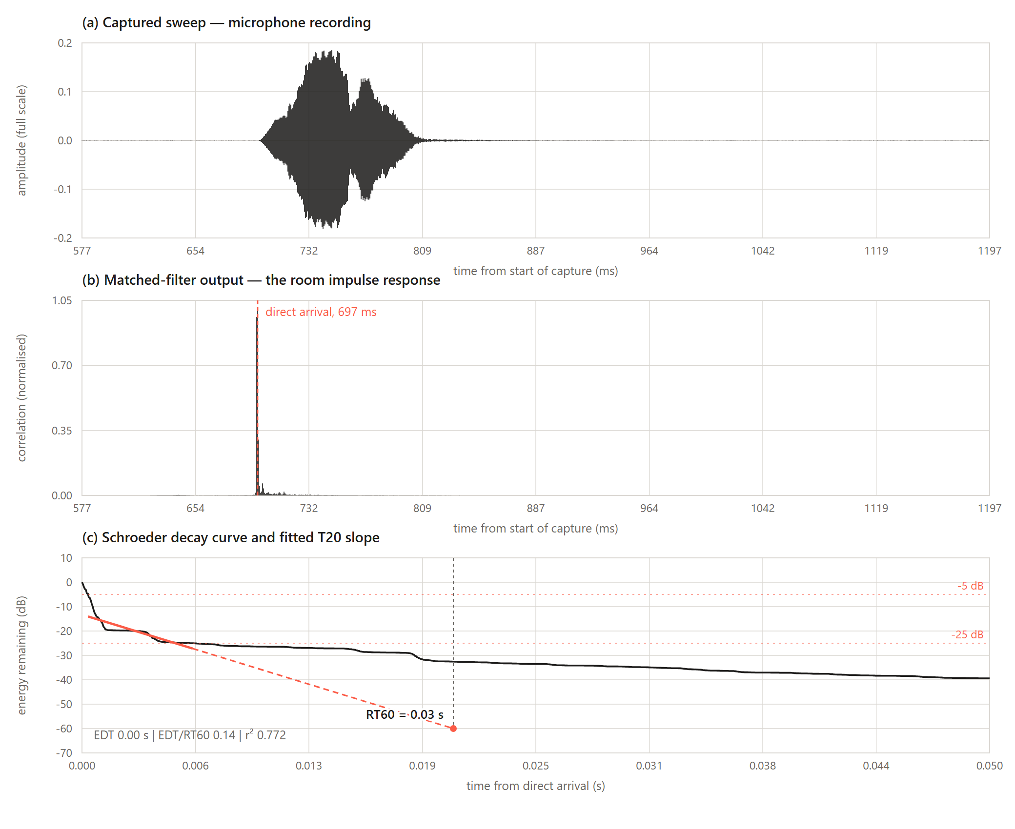
Figure 4.7: A Captured FMCW Sweep, its Correlation, and the Fitted Decay Curve. Capture 3 of Table 4.9, taken in a quiet room of about 8 m × 10 m using the 2–8 kHz sweep. Panels (a) and (b) show the emission and the matched filter compressing it to a sharp impulse response; panel (c) shows the T20 fit falling inside the collapse of the direct pulse rather than the room’s decay — the failure diagnosed in §4.3.6.

4.1.10 Implementation of the Accessibility and Motion Services
Guidance is delivered as synthesised speech and haptic patterns, so the system is usable with the phone in a pocket and the screen dark.
A single AudioArbiter mediates every use of microphone and speaker, since the voice interface and the acoustic pipeline want the same hardware. StepService wraps Android’s hardware TYPE_STEP_COUNTER rather than deriving steps from raw accelerometer data, so the count survives the phone being held still while a walker reads a sign. Distances are stored in metres but spoken in the walker’s own paces: StrideCalibrationCubit measures step length, and an uncalibrated user falls back to a documented default rather than being blocked.
One principle governs the subsystem: distance is a measurement, never a decision. Where ARCore is available it measures along-leg progress better than counting footfalls against an estimated stride, and that number is reported to the guidance engine. It can never advance a leg, end a route or move a walker onto another — landmarks do all of that, and a distance disagreeing with a sign is the distance that is wrong. This keeps the route working unchanged on phones with no ARCore and no step counter.

4.2 Testing
Verification is by automated test at unit and widget level, supported by walked trials on physical hardware for anything involving the camera, microphone, step counter or ARCore. Table 4.5 summarises the automated suite.
Measure | Value
Test files | 64
Test cases | 927
Lines of test code | 18,258
Ratio of test to production code | approximately 1 : 2.2
Table 4.5: Automated Test Suite Summary

4.2.1 UI Testing
Widget tests render principal screens against fake repositories and assert that each state branch produces the right interface, in both themes. Covered screens include the plan editor, room trace, navigation, room navigate and the room-plan probe, with the shared painters and views (floor_plan_painter_test.dart, route_map_view_test.dart, room_plan_view_test.dart).
Tests assert behaviour a user would notice — that the room sheet refuses to add a room before a category is chosen, that a route is drawn in both themes, that an error state shows a readable message rather than an exception.

4.2.2 Database Testing
Persistence is tested at the repository boundary: caching behaviour (repository_mixin_test.dart), draft isolation from published plans, and JSON round-tripping (room_plan_repository_test.dart, route_repository_test.dart, building_repository_test.dart, settings_repository_test.dart).
The round-trip tests matter more than they appear to. A plan must survive encoding to JSON, storage in PostgreSQL and decoding back with its nested geometry intact; a silent change in that path would corrupt plans rather than fail loudly, so the tests pin the exact shape.

4.2.3 Integration Testing
Integration is tested by substituting fakes at the service boundary, so a Bloc’s behaviour under a stream of frames, steps or poses is exercised without a device. guidance_bloc_test.dart, ar_guidance_cubit_test.dart and floor_map_bloc_test.dart cover the paths where components must agree — that a confirmed landmark advances a leg, that reported distance refines but never overrides it, that losing the walker triggers recovery rather than silence.
Pure cross-module pipelines are tested end to end without mocks at all: traced geometry through cleanup, graph derivation, routing and direction generation (room_plan_bridge_test.dart, room_directions_test.dart, graph_route_path_test.dart, route_registration_test.dart).

4.2.4 System Testing
System testing was carried out by walking routes in real buildings on a physical Android device, since camera, microphone, step counting and AR tracking cannot be exercised in a host test environment. Both navigation modes were walked against floors traced by the team.
The procedure for characterising augmented-reality guidance — odometry scale, yaw drift and off-route distance — is documented in docs/ar-navigation-accuracy.md.

Two Android handsets were used, and the difference between them is itself part of what is under test. Everything involving augmented reality was exercised on an Infinix Note 50 Pro, model X6855, specified in Table 4.6. It is ARCore-certified and carries Google Play Services for AR, so it can run the registered-arrow path in full. The last row of that table is a measurement rather than a manufacturer figure: the rate at which the camera background renderer actually presented frames during a walk.

Property | Value
Device | Infinix Note 50 Pro (model X6855)
Chipset | MediaTek Helio G100 Ultimate, 6 nm
CPU | Octa-core — 2 × 2.2 GHz Cortex-A76, 6 × 2.0 GHz Cortex-A55
GPU | Mali-G57 MC2
Memory | 8 GB RAM, 256 GB UFS 2.2 storage
Display | 6.78-inch AMOLED
Operating system | Android 16
Augmented-reality support | ARCore-certified; Google Play Services for AR (com.google.ar.core) installed
Sensors exercised | Rear camera, microphone and speaker, hardware step counter (TYPE_STEP_COUNTER), inertial sensors by way of ARCore
Measured camera-preview rate | Median 16.64 ms per presented frame — 60.1 fps — read from dumpsys SurfaceFlinger
Table 4.6: Augmented-Reality Test Handset Specification

The second handset is an Infinix Smart 5, model X657C — a MediaTek Helio A20 running Android 10 at API level 29, an entry-level device released in 2020 — on which the application was developed and run throughout. ArCoreApk reports it uncertified: a capability request returns −100, and no arrow can be drawn on it. That is precisely its value here. Every path exercised on it needs no ARCore, so the claim in §4.3.2 — that map-and-sound guidance runs on ordinary uncertified hardware, which is what most of this project’s intended users own — is tested rather than asserted. The acoustic captures in §4.3.6 were taken on the same device.
The walked trials were carried out in the College of Science building at KNUST, on its first floor, against a plan the team traced through the application’s own tracing flow and scaled by a measured span (§4.1.5). The traced floor covers the corridor and the rooms opening off it, carrying the building’s own numbering FF1 through FF24, while the washroom and the stairwell appear as named landmarks. Eight routes were walked door to door — three under map-and-sound guidance and five under augmented-reality guidance — each beginning at the doorway of the room the walker declared themselves to be in and ending at a destination chosen before setting off, since the AR registration solves its rotation from that first heading (§4.1.7).
The routes were spread across the floor rather than repeated along one corridor, so no single run carries the result: the map-and-sound walks cross the floor in both directions, and the AR walks mix numbered rooms with the washroom and the stairwell as endpoints, including two that begin where an earlier one ended. Each walk is recorded individually in Table 4.8 (§4.3.3).

4.3 Results

4.3.1 Functional Results
The system delivers end to end: a contributor traces a floor plan and publishes it; another user loads it, chooses a destination, and is guided there turn by turn. Table 4.7 records the outcome against each revised objective in Chapter One.
Objective (revised, Chapter One) | Outcome
1. Human-in-the-loop plan authoring | Delivered — metrically scaled plans, draft-protected
2. Navigable graph from traced geometry | Delivered
3. Graph-based route planning (A*) | Delivered — door-to-door, with spoken instructions
4. Map-and-sound guidance | Delivered — walked trials reached the destination
5. AR route registration and arrow | Delivered — with landmark re-anchoring; heading accuracy is the open issue
6. On-device semantic detection | Delivered — obstacle alerts and sign reading
7. Acoustic room classification (DSP) | Delivered — awaiting threshold re-fitting against measured rooms
8. Crowdsourced repository, local-first | Delivered
9. Evaluation and documented performance boundaries | Partially delivered — walked trials complete, quantitative measurement outstanding (§4.3.5)
Table 4.7: Revised Objectives against Delivered Outcome

4.3.2 The Two Navigation Modes
EchoLocate presents a planned route in two ways, co-equal features serving different users and different hardware, not a primary mode and a fallback.
Map-and-sound guidance draws the route over the plan and speaks the walk turn by turn with haptic cues and step counting. Needing no camera and no ARCore, it runs on any Android phone and is the mode a blind or low-vision user walks in. Augmented-reality guidance adds a registered arrow laid into the building, for a sighted walker who would rather see the way than hear it.
Both are driven by the same GuidanceBloc over the same A* route; the AR layer only mirrors the current leg into the camera and can be toggled off mid-walk. Route, instructions and arrival logic are identical in both.
This division is a design position, not a limitation. ARCore certification is a property of the handset, and the phones most widely owned in this project’s setting are not certified. A system whose navigation depended on ARCore would be unavailable to most of the people it is meant to serve, so map-and-sound guidance is expected to be the more used of the two and was built to that standard rather than as a degraded alternative.

4.3.3 Walked Trial Results
Routes were walked in real buildings against traced floors, in both modes.
Map-and-sound guidance was successful. Following the spoken guidance, a walker arrives at the intended destination; the instructions name the right rooms and doors in the right order, and arrival is announced.
Augmented-reality guidance was functional, with heading inaccuracy. The arrow appears, registers into the room and re-anchors at landmarks, but its heading is not consistently accurate over a full route. The registration solves rotation from a single observed heading at the start of the walk (§4.1.7), so an error there propagates until the first confirmed landmark corrects it.
One contributing factor was found and corrected while preparing this chapter: the minimum leg length for wall-grid voting had been reduced from 2.5 m to 0.5 m, letting route segments far too short to indicate a building’s orientation influence the grid that sets the arrow’s yaw. The threshold has been restored (§4.3.4). The walked trials predate that correction, so the heading behaviour should be re-observed before the measurements in §4.3.5.
The interpretation is straightforward. The mode that must work for the project’s primary users — eyes-free, on uncertified hardware — is the mode that works, and the mode with an open accuracy problem is the optional overlay on top of it. That follows from the architecture in §4.1.10: distance and pose refine guidance while landmarks decide it, so an inaccurate arrow cannot mislead the underlying route.
Table 4.8 records every route walked, the mode it was walked in, and whether the walker reached the destination.
Building | Floor | Start | Destination | Mode | Outcome
College of Science | First (FF) | FF1 | FF12 | Map-and-sound | Reached destination
College of Science | First (FF) | FF24 | FF17 | Map-and-sound | Reached destination
College of Science | First (FF) | FF12 | FF5 | Map-and-sound | Reached destination
College of Science | First (FF) | Washroom | FF1 | Augmented-reality | Reached destination
College of Science | First (FF) | Stairwell | Washroom | Augmented-reality | Reached destination
College of Science | First (FF) | Washroom | FF12 | Augmented-reality | Did not reach destination
College of Science | First (FF) | Stairwell | FF18 | Augmented-reality | Reached destination
College of Science | First (FF) | FF1 | FF24 | Augmented-reality | Did not reach destination
Table 4.8: Routes Walked in Both Navigation Modes, with Outcome

4.3.4 Test Results
All 927 tests pass.
One defect found while preparing this chapter illustrates what the suite is for. The case in route_registration_test.dart asserting that a path with no leg long enough has no grid was failing, expecting null and receiving 0.0, because the minimum grid-voting leg length had been reduced from 2.5 m to 0.5 m.
The consequence was not cosmetic. That path is the corridor centreline measured door to door, so its shortest legs are the hop from a doorway onto the centreline. Letting those vote meant a doorway jink could rotate the estimated grid, and that grid sets the arrow’s yaw. The threshold has been restored and the test passes.
At the time of writing, flutter analyze reports 12 issues and no errors, flutter test reports 927 passing and none failing, and flutter build apk --debug produces a build. Any claim in this chapter can be checked by running those three commands.

4.3.5 Outstanding Measurement
Quantitative measurement has not yet been carried out: the walked trials establish that guidance works but do not put numbers on how well. Three measurements remain — dimensional accuracy of traced plans against a calibrated tape measure across at least three environments (a small room, a corridor, an open hall); acoustic classification accuracy across room types, which will also re-fit the thresholds in Table 4.4; and navigation success rate over repeated runs in both modes, for sighted and eyes-free users.
Automated testing establishes that instructions are generated consistently from geometry; it cannot establish that an instruction is correct in the building. The walked trials in §4.3.3 are the first evidence that it is, and quantifying that is the next step.

4.3.6 Acoustic Pipeline: First Measurement and Diagnosis
A first attempt at the acoustic measurement described in §4.3.5 was carried out on the Infinix X657C in a quiet room of approximately 8 m × 10 m. Three captures were taken through the application’s own Room Acoustics screen, each recording retained so the pipeline could be re-run offline. The attempt did not produce a usable reverberation time, and the reason is specific and consequential enough to record here.
Table 4.9 gives the three captures. The first two used the implemented 13–19 kHz band; the third repeated the measurement with the originally proposed 2–8 kHz sweep, so the effect of the band could be separated from everything else.
Capture | Band | Recorded peak | RT60 | Fit r² | Decay range
1 | 13–19 kHz | 0.052 | 0.002 s | 0.935 | 18.1 dB
2 | 13–19 kHz | 0.051 | 0.006 s | 0.748 | 18.2 dB
3 | 2–8 kHz | 0.194 | 0.026 s | 0.772 | 20.0 dB
Table 4.9: Three Acoustic Captures in a Quiet 8 m × 10 m Room
No room has a reverberation time of two milliseconds. Sabine’s relation places a space of these dimensions, at ordinary ceiling height and furnishing, between roughly 0.4 s and 1.4 s, so the estimates are wrong by more than an order of magnitude. Capture 1 nevertheless satisfied the reliability gate described in §4.1.9 — r² of at least 0.9 across at least 10 dB of decay — and was classified as a small room. Because the confidence term rises as RT60 falls further below smallRoomMaxRt60, it was returned at almost full confidence: the more physically impossible the measurement, the more certain the classifier appears. Captures 2 and 3 were rejected, but on r² alone, which reflects how noisy the noise floor happened to be rather than any test of physical plausibility.
The cause is neither a dead room nor a failed emission. Matched filtering recovered the sweep cleanly in every capture, at 2666 times the noise floor in capture 1, and Figure 4.7 shows the impulse response it produces. The energy decay curve was therefore re-fitted over successively later windows, with the result in Table 4.10.
Fit window | RT60 at 13–19 kHz (capture 1) | RT60 at 2–8 kHz (capture 3)
−5 to −25 dB (implemented) | 0.002 s (r² 0.935) | 0.026 s (r² 0.772)
−20 to −40 dB | 0.081 s (r² 0.867) | 0.173 s (r² 0.950)
−30 to −50 dB | 19.2 s (r² 0.855) | 0.288 s (r² 0.993)
Table 4.10: Reverberation Time Recovered over Successively Later Fit Windows
The room’s decay is present in the recording; the implemented fit window does not reach it. ISO 3382 specifies the T20 fit between 5 dB and 25 dB below the initial level, a convention assuming a source separated from the receiver. In EchoLocate both sit on one handset a few centimetres apart, so the direct sound dominates the total energy against which Schroeder integration normalises. The entire −5 to −25 dB window therefore closes within six milliseconds, wholly inside the collapse of the compressed direct pulse, and never reaches the reverberant field that begins some 30 dB further down. Moved later, the fit converges: 0.288 s at r² = 0.993 for the 2–8 kHz capture, credible for a furnished room of this size.
The band is a second and lesser constraint. At 13–19 kHz the decay can be followed only to about −40 dB before meeting the noise floor, so the later windows that recover a plausible figure at 2–8 kHz collapse into noise — the 19.2 s entry in Table 4.10 is the noise floor being fitted, not a room. The near-ultrasonic band does lower the ambient noise contribution, as §4.1.9 argues, but it radiates less usable power from a phone speaker and is absorbed more rapidly in air; for reverberation the quantity being measured is precisely the part that disappears first. The justification in Table 4.3 considered the noise floor and not the dynamic range above it.
Two corrections follow, neither yet made. The fit window must be placed relative to the onset of the reverberant decay rather than to total energy, either by excluding the direct pulse before integration or by fitting a later span such as T30. Separately, the analyser needs a physical plausibility floor below which a decay is refused rather than fitted, since no room decays in milliseconds. Until both are in place the classification-accuracy study of §4.3.5 cannot meaningfully be run: the thresholds in Table 4.4 are stated in seconds, and the corridor branch requires an RT60 of at least 0.4 s, which the pipeline never produces.
This is one room, one device and three captures, offered as a diagnosis rather than a characterisation of the method. It does establish where the fault lies — in the analysis window rather than the emission, the recording or the room — which is the more useful thing to know, since the signal chain up to and including the impulse response is demonstrably sound.

REFERENCES
Duda, R. O., & Hart, P. E. (1972). Use of the Hough transformation to detect lines and curves in pictures. Communications of the ACM, 15(1), 11–15.
Faggion, F., Dominici, D., Grussenmeyer, P., & Tournadre, V. (2020). Handheld devices and apps for 3D indoor mapping: An overview. Remote Sensing, 12(10), 1621. https://doi.org/10.3390/rs12101621
Fischler, M. A., & Bolles, R. C. (1981). Random sample consensus: A paradigm for model fitting with applications to image analysis and automated cartography. Communications of the ACM, 24(6), 381–395.
Google. (2024). ARCore developer documentation. Google Developers. https://developers.google.com/ar
Google LLC. (2021). Google Measure AR app – ARCore developer documentation. Google Developers. https://developers.google.com/ar/develop/
Gu, Y., Lo, A., & Niemegeers, I. (2015). A survey of indoor positioning systems for wireless personal networks. IEEE Communications Surveys & Tutorials, 11(1), 13–32. https://doi.org/10.1109/SURV.2009.090103
Hart, P. E., Nilsson, N. J., & Raphael, B. (1968). A formal basis for the heuristic determination of minimum cost paths. IEEE Transactions on Systems Science and Cybernetics, 4(2), 100–107.
ISO. (2008). ISO 3382-2: Acoustics — Measurement of room acoustic parameters — Part 2: Reverberation time in ordinary rooms. International Organization for Standardization.
Leica Geosystems. (2022). Leica BLK360 imaging laser scanner – Technical specifications. Hexagon AB. https://leica-geosystems.com/products/laser-scanners/scanners/blk360
Locometric. (2022). RoomScan Pro – Floor plan app for iPhone and iPad. Apple App Store. https://apps.apple.com/app/roomscan-pro/id673673795
Mirowski, P., Ho, T. K., Yi, S., & MacDonald, M. (2013). SignalSLAM: Simultaneous localisation and mapping with mixed WiFi, Bluetooth, LTE and magnetic signals. In Proceedings of the 2013 International Conference on Indoor Positioning and Indoor Navigation (IPIN) (pp. 1–8). IEEE. https://doi.org/10.1109/IPIN.2013.6817853
Nielsen, J. (1994). Usability Engineering. Morgan Kaufmann.
Prattico, F. G., Lamberti, F., Cannavaro, I., Morra, L., & Montuschi, P. (2021). Comparing state-of-the-art and emerging augmented reality interfaces for autonomous vehicle external human–machine interaction. IEEE Transactions on Vehicular Technology, 70(3), 2487–2500. https://doi.org/10.1109/TVT.2021.3054338
Republic of Ghana. (2012). Data Protection Act, 2012 (Act 843). Accra: Ghana Publishing Company.
Sabine, W. C. (1922). Collected Papers on Acoustics. Harvard University Press.
Schroeder, M. R. (1965). New method of measuring reverberation time. Journal of the Acoustical Society of America, 37(3), 409–412.
Sensopia. (2023). MagicPlan – Floor plan & home design application. App Store & Google Play. https://www.sensopia.com/
Umeyama, S. (1991). Least-squares estimation of transformation parameters between two point patterns. IEEE Transactions on Pattern Analysis and Machine Intelligence, 13(4), 376–380.
World Wide Web Consortium (W3C). (2018). Web Content Accessibility Guidelines (WCAG) 2.1. W3C Recommendation.

